Project Report

|  |  |
| --- | --- |
| Project Title | Design, Develop, Implement, Test & Document Used Car Sales Portal Website |
| Qualification Name (NICF) | Advanced Certificate in Software Applications (Development and Process) |
| Product Name | ABC Cars Pte Ltd Portal |
| Module Name (NICF) | Application Development & Process |

|  |  |  |  |
| --- | --- | --- | --- |
| Student name | | Assessor name | |
| Darren Farrell | |  | |
| Date issued | Completion date | | Submitted on |
|  | 06/05/2023 | | 06/05/2023 |
|  | |  | |
| Project title | Design, Develop, Implement, Test & Document Used Car Sales Portal Website | | |

|  |
| --- |
| Learner declaration |
| I certify that the work submitted for this assignment is my own and research sources are fully acknowledged.    Student signature: Date: 05/05/2023 |

Content

1. **Project Background**
2. **Project Objectives**
3. **Project Requirement Specifications**
4. **Task 1**
5. **Task 2**
6. **Task 3**
7. **Task 4**
8. **Task 5**
9. **Task 6**
10. **Task 7**
11. **Task 8**

1. Project background

You have been approached by ‘ABC Cars Pte Ltd’ as a website developer to develop a Used Car Sales portal. Users will be able to register in the portal using the Registration Page. Users of the portal can search for Cars using Make, Model, Registration & Price Range. Users will be able to view the Car information after searching them. The portal allow users to login, post Car for sale. Administrator will be able to manage the users, cars, bidding, and appointment. The Website will be implemented using spring boot framework which include Spring, Security, Spring Data JPA, MySQL server, documented and tested by adopting the Risk Based Testing (RBT).

Project Objective

The Project objective of this project is the following

* Design and develop a sales portal for used cars using Spring Boot framework, Spring Security, Spring Data JPA, and MySQL server.
* Apply the Risk-Based Testing (RBT) strategy or spiral SDLC model to prepare a testing plan for validating client requirements.
* Document the used car sales portal website based on the spiral model.
* Execute and record necessary testing under RBT.
* Identify and analyze risks associated with the used car sales portal.
* Solve problems based on the RBT test plan.

**Tools & platform used**

|  |  |
| --- | --- |
| Software | Purpose |
| Spring Tool Suite 3 | Java IDE used to develop java based used car sales website |
| MySQL Workbench | For the database management |
| Chrome DevTools | for performance testing and inspecting developed website |
| Lambdatest.com | For cross browser testing |
| Microsoft Word | Used to write Application Development & Process report |

STS 3

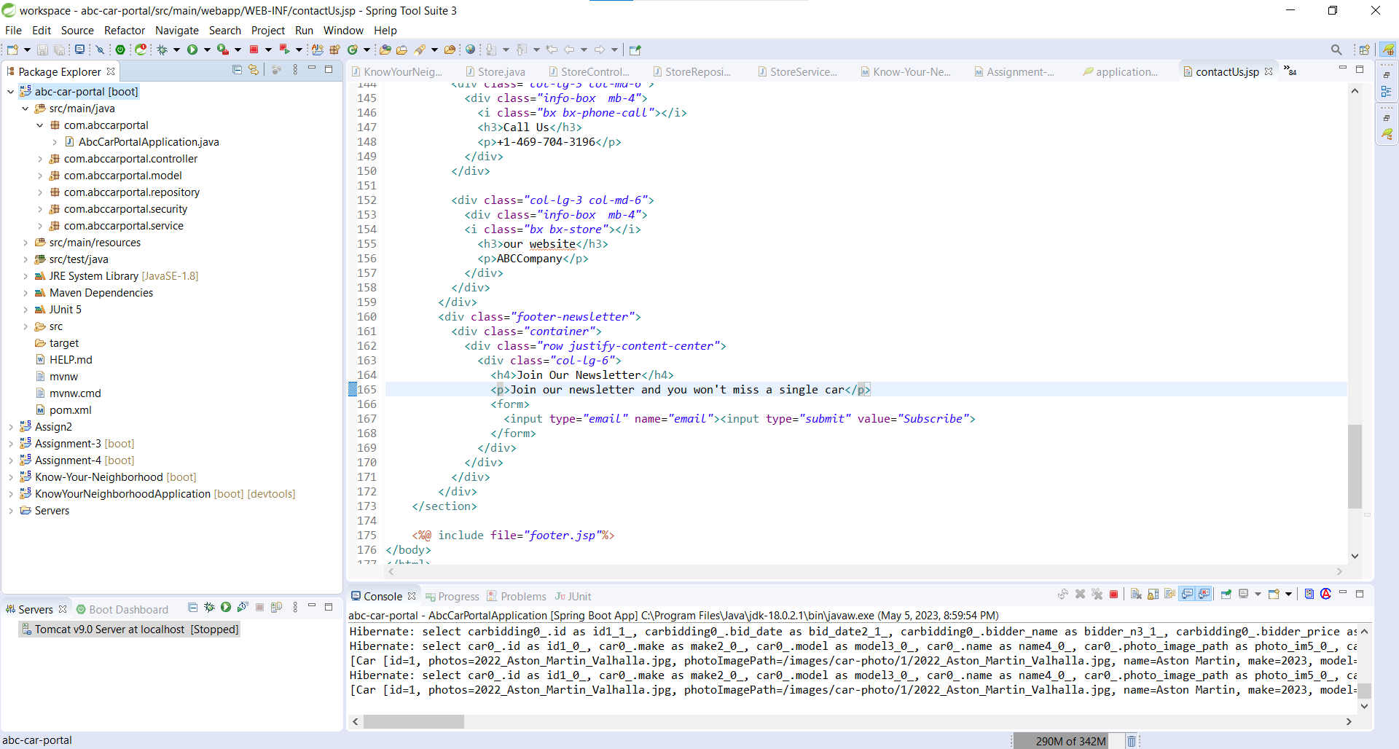

MySQL Workbench

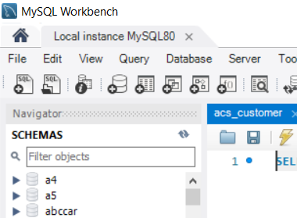

Lambda test

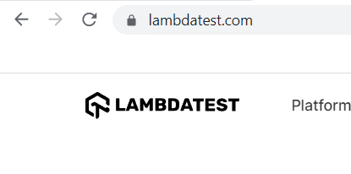  
Chrome Dev Tool

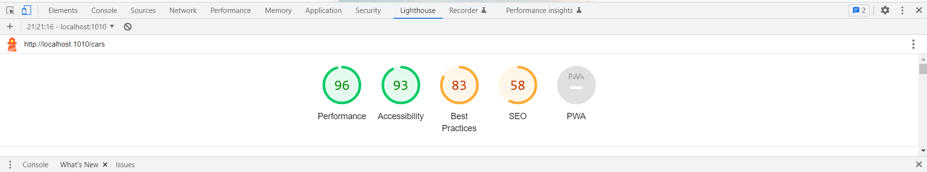

Microsoft word and Powerpoint

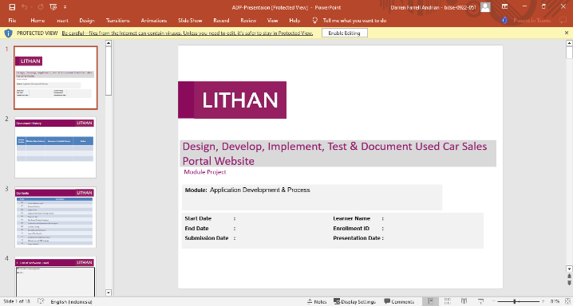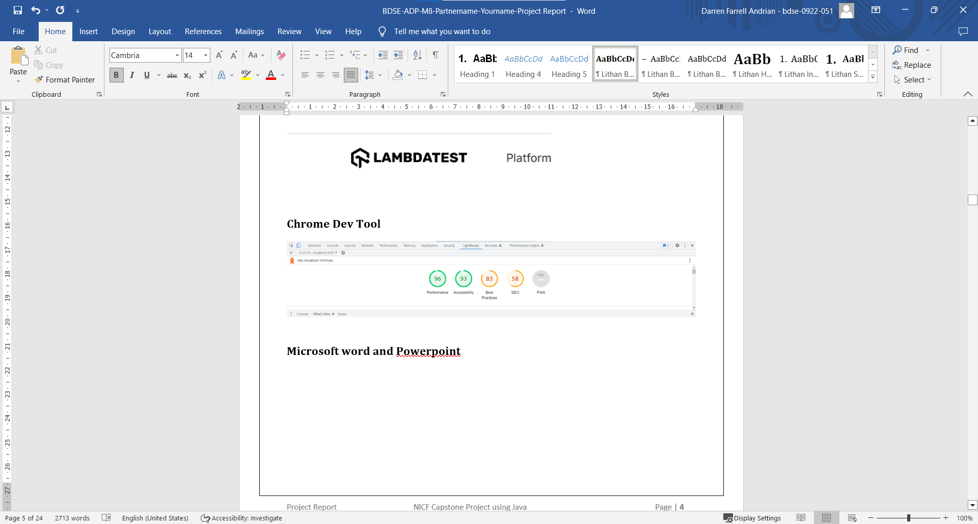

Project Requirements Specifications

* 1. Project Scope

There are 2 types of users in this Used Cars Sales portal. They are

* Users
* Administrator

User

* Register Page
* Login Page
* Post the Car for sale
* View Car Details
* Visit Home Page
* View Car Listing
* Delete their own car listing
* Search Car by make, model, registration & Price Range
* Bid for the car
* Book for a test drive
* View About Us Page
* View Contact Us Page
* Update profile
* Logout

Admin

* Login into administrator panel
* Manage Cars and its bidder and booked
* Manage users
* Logout
* Visit Home Page
* View Car Listing Page
* View About Us Page
* View Contact Us Page
* Search Car by make, model, registration & Price Range

3.2 Functional Requirement

The following pages will be developed and displayed in the project:

1. Registration Page
2. Login Page
3. About Us Page
4. Contact Us Page
5. Home Page
6. Post Car Page
7. Car List Page
8. Car detail page
9. Search Car Results Page
10. Update Profile page
11. User management page
12. Car management page

Task 1

Task Statement:

Create the following items Under “Business Process Section” in Project Presentation

1. Explain the Business Processes the Software is supporting
   1. Document 2 Business Process
2. Document 2 Module functionality
   1. UI Screenshots
   2. Functionality of each of the Screen

Solution:

* 1. Explain the Business Processes the Software is supporting
  2. Document 2 Business Process
     1. Scenario 1 - Post Car
  3. Access the ABCcar website by typing "http://localhost:1010" in the URL field.
  4. Click on the "Register" button and fill in the required details, such as name, username, email, and password, to create a new user account.
  5. After successful registration, a confirmation message will be displayed with a link to the login page.
  6. Enter the registered username and password on the login page to access the portal.
  7. The user will be directed to the home page displaying a list of all cars posted by other users.
  8. To post a car for sale, click on the "Sell Now" button on the home page, fill in the car's details, such as name, model, price, make year, registration date, and photo, and click on the "Post" button.
  9. After successful posting, a confirmation message will be displayed with a link to the car's detail page.
     1. Scenario 2-

1. Access the used car sales portal by typing "http://localhost:1010" in the URL field.
2. Click on the "Register" button and fill in the required details, such as name, username, email, and password, to create a new user account.
3. After successful registration, a confirmation message will be displayed with a link to the login page.
4. Enter the registered username and password on the login page to access the portal.
5. The user will be directed to the home page displaying a list of all cars posted by other users.
6. To search for a car, navigate to the search bar on the header.
7. Enter search keywords such as make, model, registration, or price to find a specific car.
8. For instance, to search for a car called supra, type "supra" in the search field and click on the "search" button.
9. The user will then see a search result page displaying a list of cars that match the search keyword.
   1. Document 2 Module functionality
   2. *UI Screenshots*

Scenario 1 - Post Car

* + Access the ABCcar website by typing "http://localhost:1010" in the URL field.

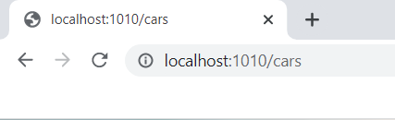

* + Click on the "Register" button and fill in the required details, such as name, username, email, and password, to create a new user account.

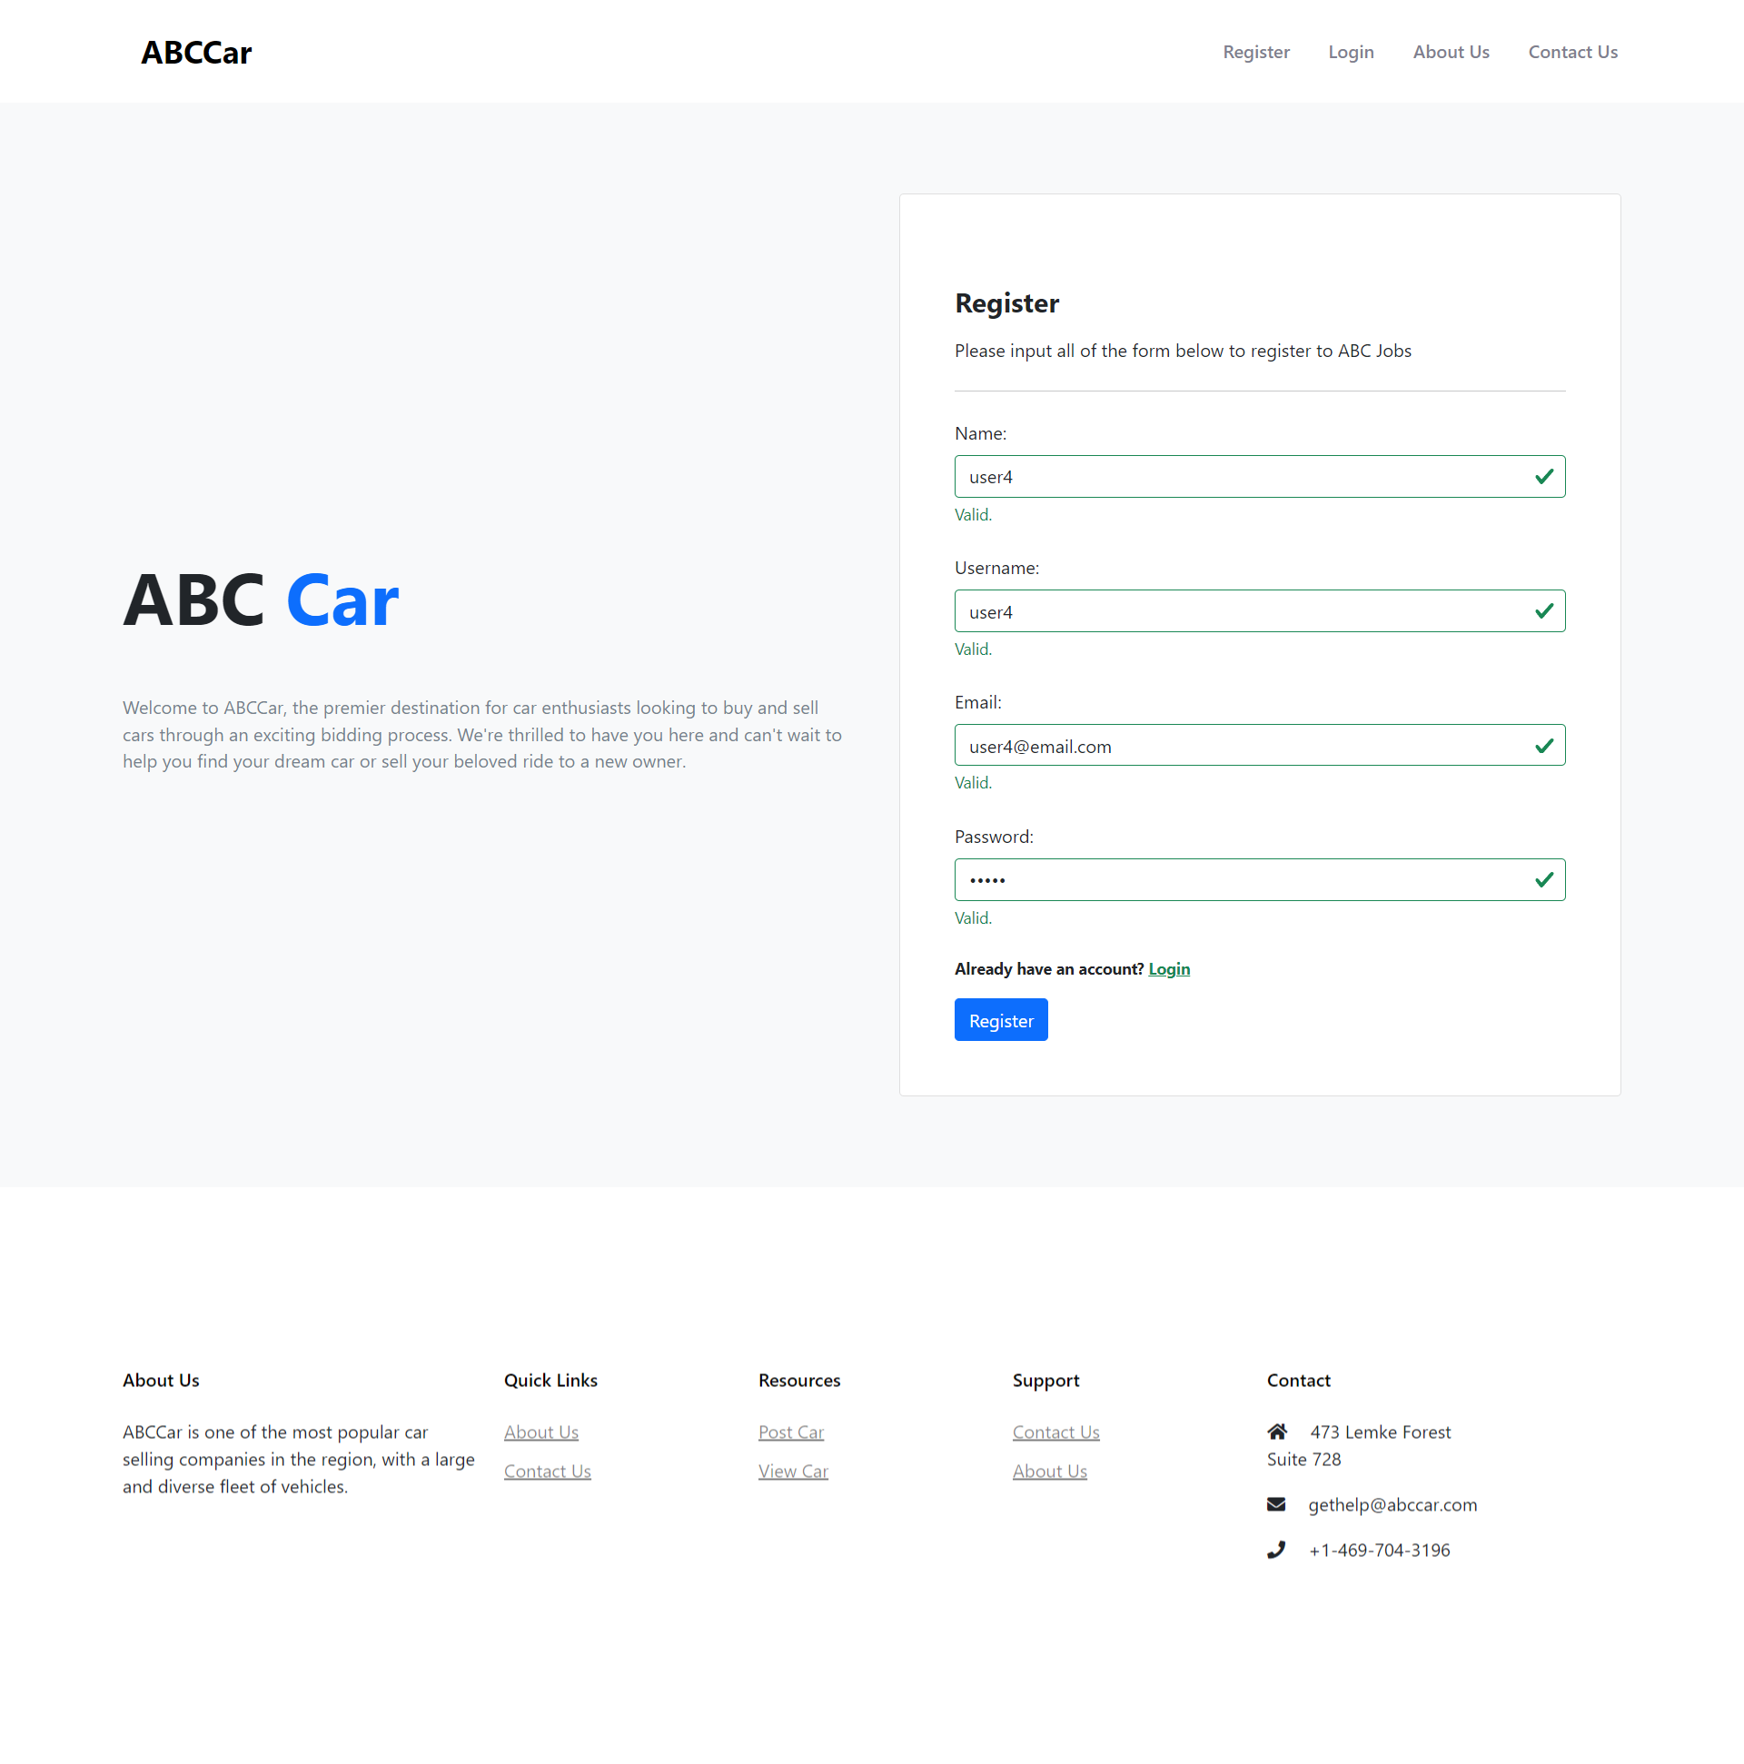

* + After successful registration, a confirmation message will be displayed with a link to the login page.

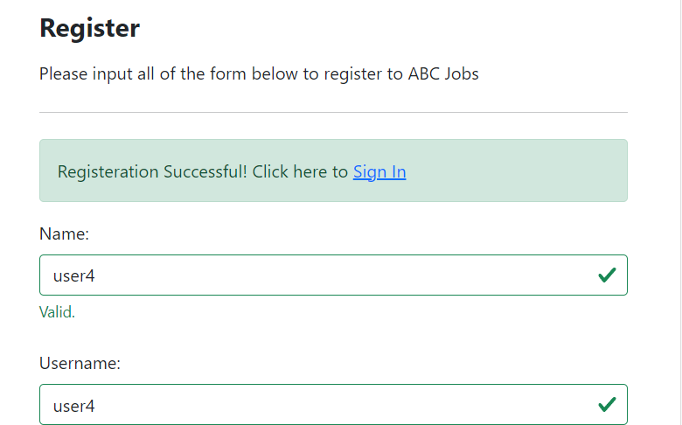

* + Enter the registered username and password on the login page to access the portal.

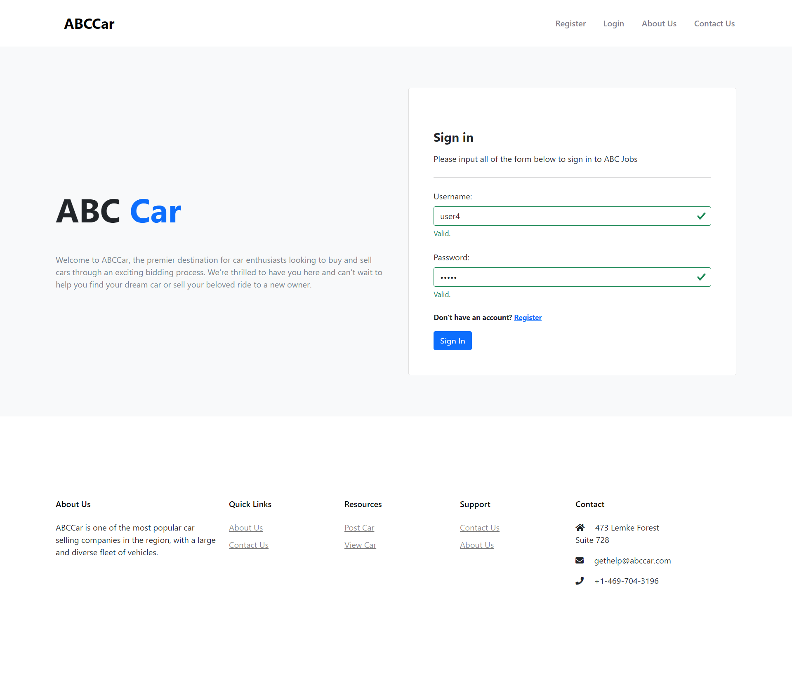

* + The user will be directed to the home page displaying a list of all cars posted by other users.

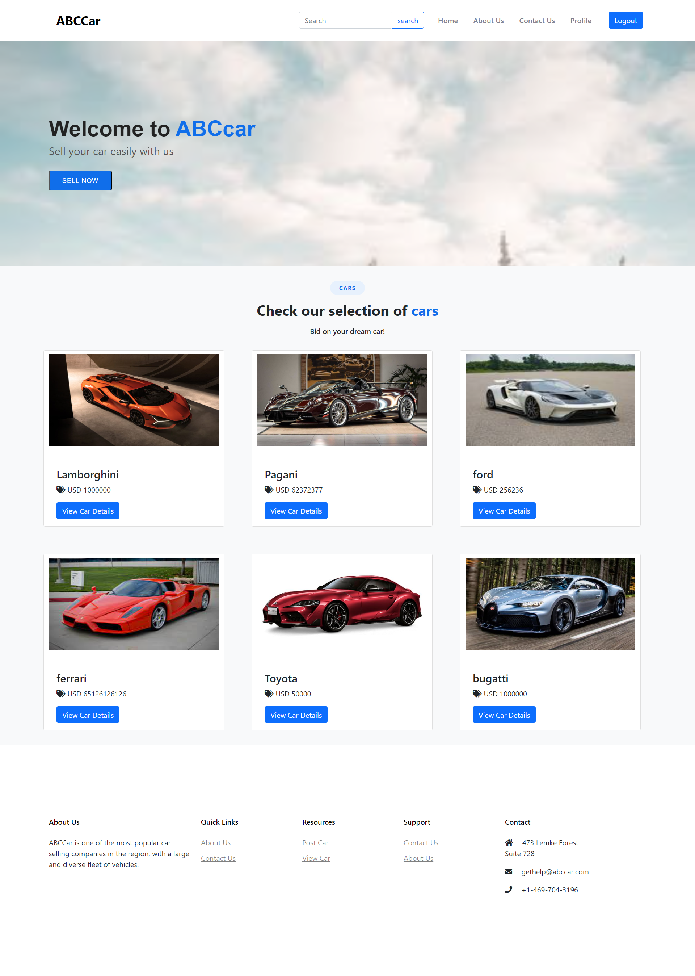

* + To post a car for sale, click on the "Sell Now" button on the home page, fill in the car's details, such as name, model, price, make year, registration date, and photo, and click on the "Post" button.

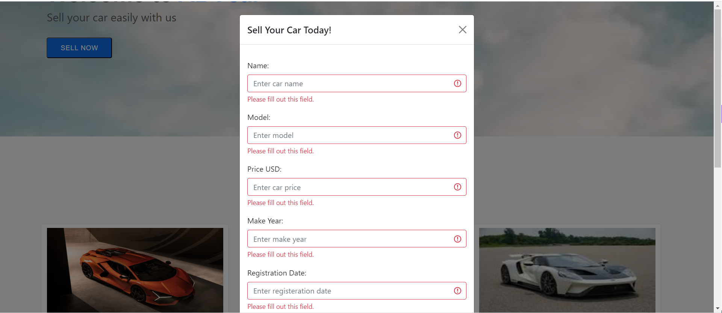

* + After successful posting, a confirmation message will be displayed with a link to the car's detail page.

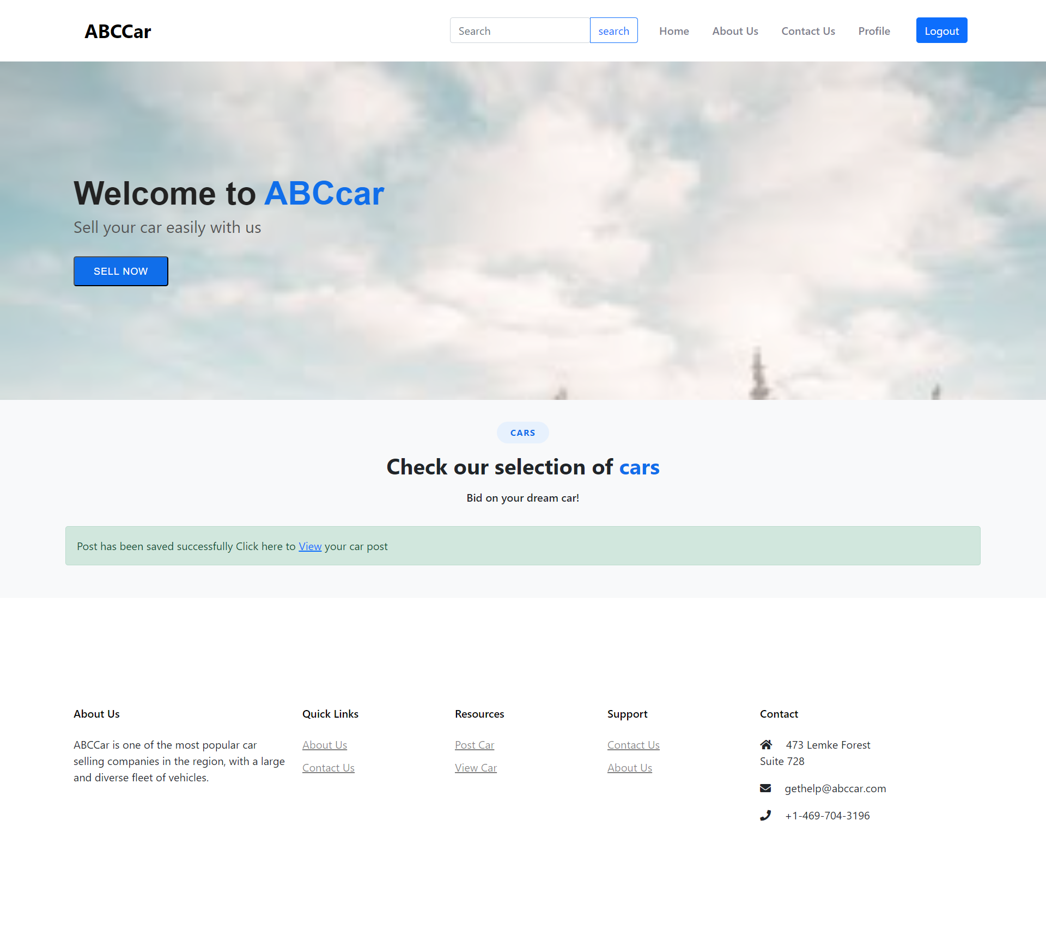

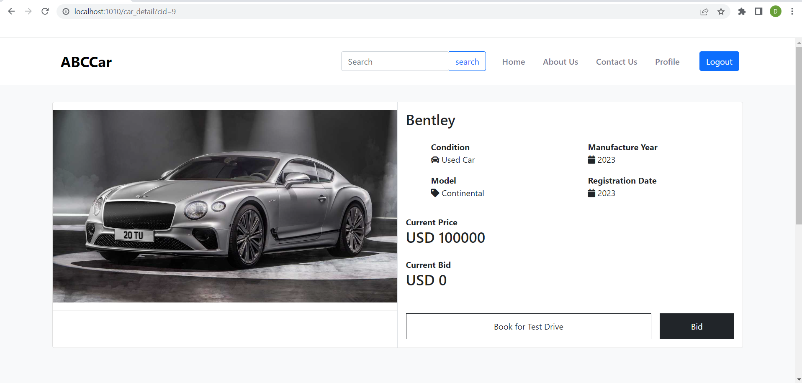

1. Scenario 2-

* Access the used car sales portal by typing "http://localhost:1010" in the URL field.



* Click on the "Register" button and fill in the required details, such as name, username, email, and password, to create a new user account.



* After successful registration, a confirmation message will be displayed with a link to the login page.



* Enter the registered username and password on the login page to access the portal.



* The user will be directed to the home page displaying a list of all cars posted by other users.



* To search for a car, navigate to the search bar on the header.



* Enter search keywords such as make, model, registration, or price to find a specific car.
* For instance, to search for a car called toyota supra, type "supra" in the search field and click on the "search" button.

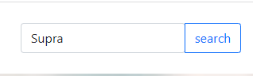

* The user will then see a search result page displaying a list of cars that match the search keyword.

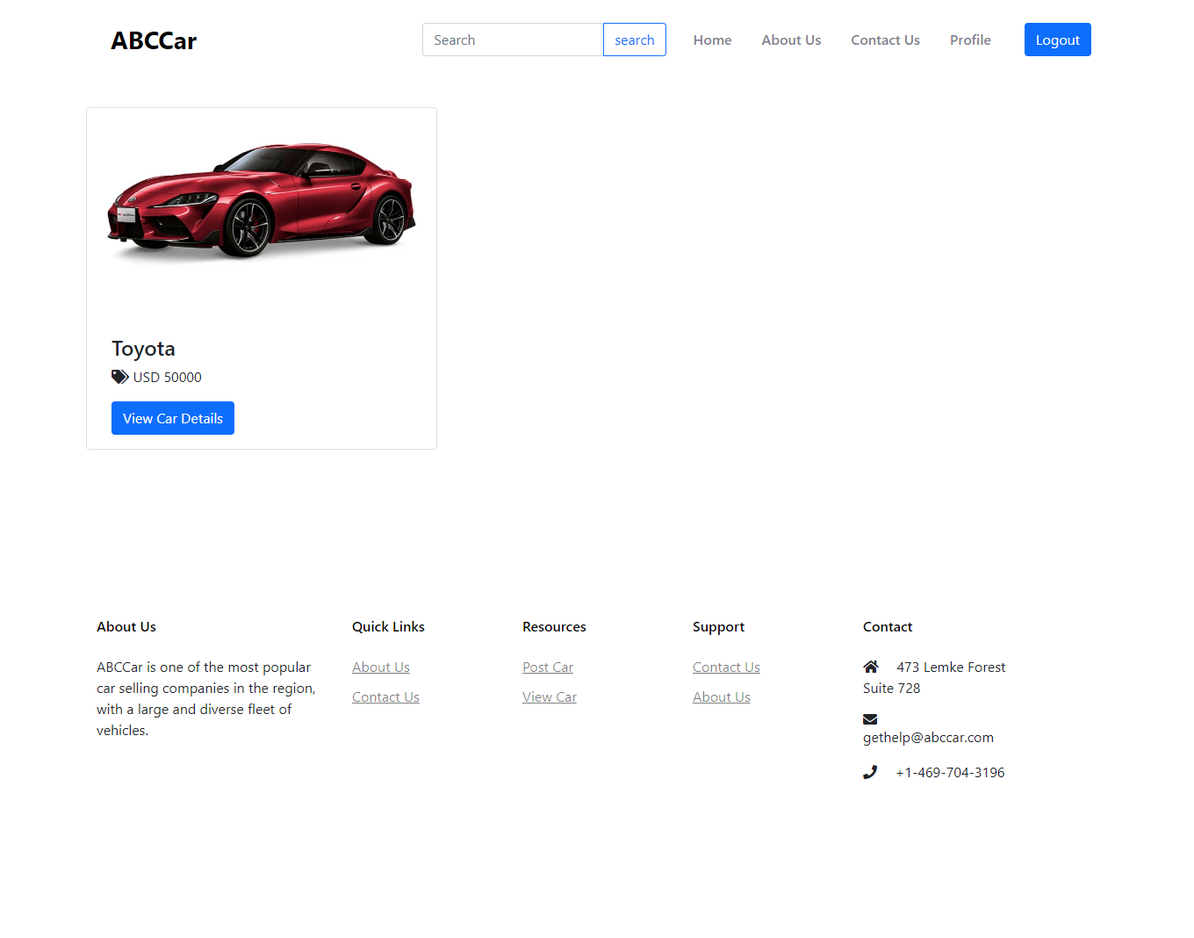

* 1. *Functionality of each of the Screen*

|  |  |
| --- | --- |
| Pages | Functionality |
| 1. Register | Allow new user to register to the ABC car website by inputting their name, username, email, and password |
| 2. Login | To log in to the ABC car website before they can access the website by validating them with registered credentials |
| 3. Home | The landing page of the website. This is also the place for the user to see all of the cars available and post a car of their own |
| 4. About Us | This is for the user to found out more about ABC car as a company |
| 5. Contact Us | Allow user to contact the ABC car company through various means |
| 6. Profile | This is where the users can view their profile, update their profile, look at their own listing and edit their own listings. |
| 7. Car Detail | Allow user to see all of the car detail and this is the place for them to bid or book an appointment |
| 8. Search result | This is the page that the user see if they use the search bar in the header to search for something |
| 9. User Management | This is where the admin will manage the user. The Administrator can delete or edit the user |
| 10. Car Management | This is where the admin can manage all of the cars listed on the website. |

Task 2

Task Statement:

Create the following items in “Project Plan in Project Presentation

1. Detail the Software Development Methodology to be used for developing system
2. List the various tasks to be done during various phases
3. Create the Project Plan detailing the various steps to be carried out along with dates and Timelines

Solution:

* 1. Detail the Software Development Methodology to be used for developing system

Spiral model.

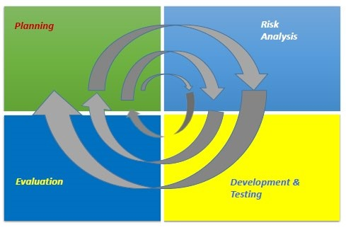

The spiral model is a development model that combines features of the iterative and waterfall models. In this model, the phases do not overlap, and each phase must be completed before proceeding to the next one. However, changes can be made at each iteration. The risk analysis phase included in the spiral model makes it an excellent choice for risk handling.

For the development of the used car sales portal, the spiral model offers several advantages. By adding features such as registration, login, and searching in a systematic way, development can be faster. If a customer is not satisfied with a function such as registration during the evaluation phase, changes can be made by going back to the development and testing phase until customer satisfaction is achieved.

In addition, the spiral model makes cost estimation easier because the prototype is done in small components. During the development phase, one function, such as registration, needs to be completed first. After successful evaluation, other functions such as login, posting, or more can be done. As a result, there will be less cost estimated for development in each cycle.

* 1. List the various tasks to be done during various phases

1. Planning:
   * 1. Business Requirement Gathering and Documentation

* Arrange a meeting with the client to gather business requirements for the website
* Prepare the Statement of Work (SOW) or scope document to document all client requirements
  + Scope includes designing, developing, implementing, testing, and documenting the used car sales portal website
    1. Project Initiation Document
* Prepare the Project Initiation Document to establish project objectives and plan
  + Project objectives include designing and developing a used car sales portal using Spring Boot framework, Spring Security, Spring Data JPA, and MySQL server
  + Implement Risk-Based Testing (RBT) strategy or Spiral SDLC model for testing plan and validation of client requirements
  + Document the used car sales portal website based on the Spiral model and execute and record necessary testing under RBT
  + Identify and analyze risks associated with the used car sales portal and solve problems based on the RBT test plan
    1. Project Cost and Resource Planning
* Construct a Cost-Benefit Analysis for the used car sales portal
* Acquire guidance from stakeholders, team members, and project managers to estimate the number of resources needed for the project and identify relevant skills
* Prepare the Project Plan Document (PPD) to finalize the schedule, including a Gantt chart to visualize the used car sales portal timeline
  + 1. System Requirement Specification (SRS) Document
* Prepare the SRS document to define the purpose of the used car sales portal based on the SOW and Project Initiation Document
* Provide specific requirements for functional and non-functional requirements, such as user registration and login, and security measures

1. Risk planning

* Prepare a Risk Management Plan Document
* Arrange a meeting with the client to identify potential risks and list them in a risk breakdown structure (RBS)
* Analyze the identified risks using a qualitative risk analysis chart.
* Develop a risk mitigation plan to reduce the impact and likelihood of risks.
* Prepare a contingency plan to address unexpected risks that may occur, such as backing up website data in case of a cyber-attack.

1. Design, development and testing

System Design:

* Prepare the System Design Document
  + Technical specifications
    - Hardware:
      * Processor: Intel I3 3rd gen and above
      * Installed RAM: 4.00 GB and above
      * Graphics card: any graphics card with 1gb vram or more
      * System type: 64-bit operating system, x64based processor
    - Software:
      * Primary Web browser: any web browser
      * Development environment: JDK 1.8 and above
      * Framework: Spring 3.9.12
    - Database:
      * Database server: MySQL
      * Database scripting: SQL script
      * Database client: MySQL Workbench
  + User Interface
    - wireframe
    - Process Flow
    - Storyboard
  + Database Design
    - Entity-Relationship Diagram
    - Logical Diagram

Software Development:

* Prepare a software development document
  + Front-End implementation:
    - Document all JSP pages source code
    - Document all CSS pages source code
  + Database implementation:
    - Document DB Schema
  + Prepare integration document
    - Business logic implementation:
      * Define the business rules:
        + Only user can post a car for sale
      * Define data exchange method from database to user interface:
        + Direct database connection using JSP
  + Prepare test case document:
    - Define the test case for unit testing:
      * Validate registration function
      * Conduct unit testing
        + Review the test case
        + Run the test cases
        + Record the result:

Compare expected to actual result

Record the result status either successful or fail

* + - * + Check the accuracy and debug
        + Make the necessary changes to the web pages
    - Conduct user acceptance testing (UAT) with the client:
      * Define the UAT test case
      * Run the UAT test case
      * Record the result

1. Customer evaluation

* Prepare a demo of the website for the customer.
* Obtain feedback from the customer and assess their satisfaction.
* Implement changes to the website based on the customer's feedback by returning to the development and testing phase if customer approval was not achieved.
* Move on to the next planning phase after obtaining customer approval until the website is fully developed.
* Verify that the website has been developed as per the SRS (Software Requirements Specification) document.
* Conduct a project sign-off between the client and the project manager.
* Prepare the product for deployment.
* Upload the developed used car sales website on the web server.
  1. Create the Project Plan detailing the various steps to be carried out along with dates and Timelines <less than a month> 20-30

|  |  |  |  |
| --- | --- | --- | --- |
| Phases | Activity | Start Date | End Date |
|  | Customer approach us to make a website for a used car sales portal | 4//4/2023 | 4/4/2023 |
| Planning | Arrange a meeting with the client to gather all of the requirement in making the portal | 5/4/2023 | 5/4/2023 |
|  | Prepare the SOW | 6/4/2023 | 6/4/2023 |
|  | Analyse all of the project objective of the used car sales website | 7/4/2023 | 7/4/2023 |
|  | Make an estimate on how much the project is going to cost | 8/4/2023 | 8/4/2023 |
|  | Plan all of the resources that is going to be used in this project | 9/4/2023 | 9/4/2023 |
|  | Finalize the schedule with a strict deadline | 10/4/2023 | 10/4/2023 |
| Risk Analysis | Prepare a risk management document | 11/4/2023 | 11/4/2023 |
|  | Arrange meeting for the potential risk | 11/4/2023 | 11/4/2023 |
|  | Prepare a risk analysis chart | 12/4/2023 | 12/4/2023 |
|  | Mitigate the risk of the analysed risk | 12/4/2023 | 12/4/2023 |
|  | Prepare a contingency plan in case of any cyber attacks | 12/4/2023 | 12/4/2023 |
| Development & Testing | List out all of the technical specification that is necessary for the creation of the website | 13/4/2023 | 13/4/2023 |
|  | Prepare the early stages of the user interface | 14/4/2023 | 14/4/2023 |
|  | Prepare the database design that is required for the website | 15/4/2023 | 15/4/2023 |
|  | Implement the user interface of the website | 16/4/2023 | 16/4/2023 |
|  | Implement the database of the website | 17/4/2023 | 18/4/2023 |
|  | Implement the business logic of the website | 19/4/2023 | 22/4/2023 |
|  | Write test cases necessary for testing the website | 23/4/2023 | 25/4/2023 |
|  | Conduct all of the testing for the website to ensure performance | 26/4/2023 | 28/4/2023 |
|  | List out all of the testing results | 29/4/2023 | 29/4/2023 |
|  | Debug the website and check the accuracy of the testing | 30/4/2023 | 1/5/2023 |
|  | Make the necessary changes to the front end depending upon the bug | 2/5/2023 | 2/5/2023 |
| Evaluation | Demo the website in front of the customer | 3/5/2023 | 3/5/2023 |
|  | Retrieve the feedback from customer and make changes based on the satisfaction | 4/5/2023 | 4/5/2023 |
|  | Conduct a project sign-off between the client | 5/5/2023 | 5/5/2023 |
|  | The ABC car portal is ready to deploy to the server | 5/5/2023 | 5/5/2023 |

Task 3

Explain risk-based testing concepts and requirements with the following details

Solution:

* 1. Stages involved in RBT model
     1. What is the risk?

Risk is a possibility of an event that can negatively impact the success of a project. We need to consider all of the risk involved in development so that there won’t be any mishap later on down the development. Handling risk as early as possible can be the detrimental factor on how the development process is going to go

* + 1. RBT stages

RBT is short for a risk-base testing strategy that centers on evaluating the most vulnerable and significant features of a software application to avert risks and guarantee the product's superiority.

Risk identification

* Ways to identify risk:
  + Brainstorming
  + Interviewing
  + Delphi technique
  + Risk breakdown structure
  + Cause & effect diagram, and so on.
* Risk categories:
  + Known risk:
    - Functional risk
    - Non-functional risk
    - Technical risk
  + Unknown risk (e.g., not anticipated during testing):
    - Insufficient resources
    - Delayed testing due to sudden defects
  + Unknowable risk (e.g., with critical impact):
    - System down for more than 1 day
    - Natural calamities

It is vital to document recognized risks in a spreadsheet or Risk Register to monitor the risk during the entire project.

Risk Strategy & Assessment

The next step is to conduct a risk analysis using the risk matrix method. This quantitative approach assesses the likelihood and impact of each risk, assigning them values that range from low to extreme. The results will provide a better understanding of the identified risks and help in prioritizing them for mitigation.

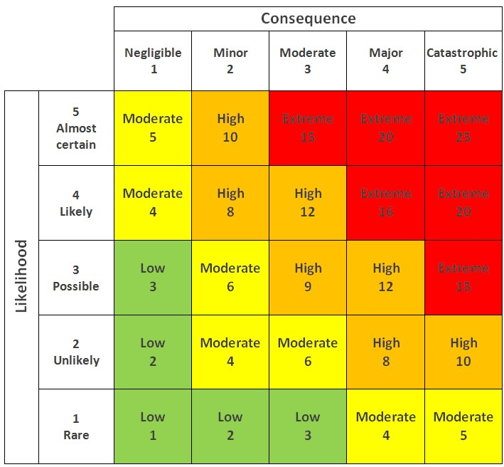

Risk mitigation

In response to identified risks, a suitable response strategy is implemented to either eliminate or minimize the impact of the risk to an acceptable level if complete elimination is not possible.

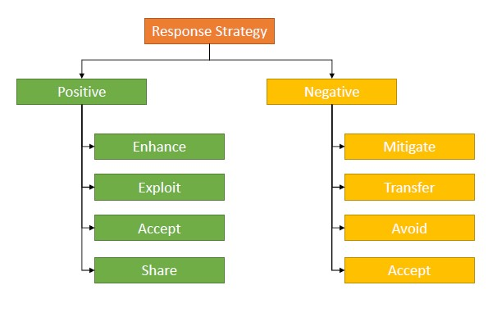

Risk monitoring and control

Monitoring and controlling risks in software development is an essential part of the process to ensure project success. This involves monitoring residual risks, identifying new risks, tracking current risks, and more. However, the risks may increase due to various reasons, including frequent changes in technology, project length and size, or a shortage of skills. Therefore, continuous monitoring is required through reassessment of risks, audits, trend analysis, or status update meetings to evaluate the effectiveness of risk reduction strategies.

* + 1. Eight characteristics of Software Product Quality

The goal for the used car sales portal is to develop it as per the ISO/IEC 25010:2011 software product quality standards. This requires testing the website's functional suitability, performance efficiency, compatibility, usability, reliability, security, maintainability, and portability*.*

Functional Suitability

Functional suitability refers to the ability of the used car sales portal to provide all the necessary functions without lacking requirements, and delivering the expected outcomes when users complete specific tasks and objectives.

Performance Efficiency

The processing speed or time of the portal is crucial to users and should not exhibit any lagging. The portal should also have the ability to accommodate many users without affecting its efficiency.

Compatibility

Compatibility pertains to the portal's ability to function efficiently in different environments or browsers.

Usability

Usability refers to the portal's capability to allow users to easily learn how to use its features, prevent errors, and provide a user-friendly interface.

Reliability

Reliability refers to the portal's ability to perform well under specified conditions in the event of any faulty software/hardware or interruption/failure.

Security

Security pertains to the portal's capability to protect data from security vulnerabilities and ensure the confidentiality of user data from unauthorized access.

Maintainability

The portal should be maintainable by allowing modifications to be made with minimal impact on other features. It should also be easy to test to determine whether defined test criteria have been met.

Portability

Portability refers to the portal's ability to adapt to different hardware and usage environments, such as laptops, iPads/tablets, or phones. The portal should also have the capability to replace another comparable product.

* 1. Types of Risk

|  |  |  |  |
| --- | --- | --- | --- |
| *Type of risk* | *Risk identification* | *Risk description* | *Impact* |
| *Functional* | *Login Failure* | *User cannot log in with registered credentials* | *The user cannot use the features of the website, buy or sell a car. They won’t be able to access the website at all* |
|  | *Posting failure* | *User cannot post a car for sale* | *User cannot sell their car through the used car portal which make the whole website useless* |
|  | *Search Failure* | *User cannot find a car* | *User can’t search the car that they wanted and they won’t be able to look at the details and can’t buy the car* |
|  | *Viewing Failure* | *User cannot view car details for selected cars* | *User cannot bid or make an appointment for a car they are interested in* |
|  | *Data loss* | *Data is not saved in the database for registered users* | *Users and administrators cannot log in or access the home page* |
| *Non-Functional Risk* | *Performance* | *Home page is not loading in expected time* | *User may lose interest and look for a different website* |
|  | *Compatibility* | *Home page has different look and feel into different browsers* | *User may find the user interface confusing and look for a different option* |
|  | *Maintainability* | *cannot be easily modified or updated* | *User may view the portal as outdated and abandon the website* |
|  | *Usability* | *User interface is confusing and difficult to navigate.* | *Users may find it difficult to locate and access the features they need, leading to frustration and potential abandonment of the website.* |
| *Technical Risk* | *Security* | *Incorrect authentication after logging in* | *User cannot access the home page and use the features of the website* |
|  | *Portability* | *Website appears differently on mobile devices* | *User who prefer mobile devices may lose interest and look for a different option.* |

1. Task 4

Task Statement

Create the following items under “Test Planning” in Project Report

1. Establish the test phases of security testing with its prioritization
2. Develop the detailed test plan with test cases based on quantitative risk analysis
3. Create a test risk matrix with the evaluation of the impact

Solution

1. Establish the test phases of security testing with its prioritization.

(a) RBT Test Strategy in car portal project

1. What is security testing?

The purpose of security testing is to identify potential vulnerabilities, threats, and risks in the used car sales portal and prevent malicious attacks from unauthorized users.

2. Types of Security Testing

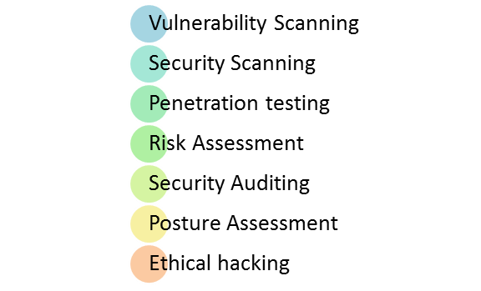

* Vulnerability scanning:

The process of scanning for potential vulnerabilities in a software application or system can be automated using tools such as Acunetix or Owasp.

* Security scanning:

This involves identifying and addressing weaknesses in network or system to reduce the risk of security breaches. It can be performed manually or through automated means.

* Penetration testing:

This testing simulates an external hacking attempt to analyze potential vulnerabilities and assess the security of a system.

* Risk assessment:

This involves evaluating security risks and categorizing them based on their level of severity. Control measures are then implemented to mitigate these risks.

* Security auditing:

This entails a line-by-line inspection of code to identify any security flaws.

* Ethical hacking:

Ethical hackers are employed to identify and expose security flaws in a system, rather than exploit them for malicious purposes.

* Posture assessment:

This assessment provides an overall view of an organization's security posture by combining security scanning, ethical hacking, and risk assessment.

(b) Among test strategies, how to carry security testing.

The ABC Cars Project’s Security Testing Process

To ensure the security of the used car sales portal, a risk assessment approach is adopted, which involves the following steps:

1. Identifying different types of risks: Various types of risks are identified and categorized, including technical risk, functional risk, and nonfunctional risk.
2. Analyzing identified risks: The risks are analyzed quantitatively using a Risk Matrix, which measures the likelihood and consequences of each risk. This helps in gaining insight into the potential risks.
3. Mitigating the risks: Once the risks are analyzed, the next step is to find the best solution to mitigate the impact of possible threats. This involves implementing control measures to minimize the risks and ensure the security of the used car sales portal.

(c) Test phases in security testing

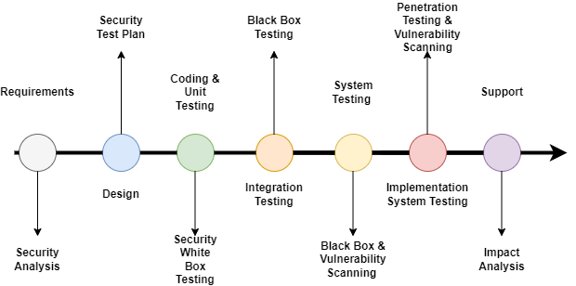



Incorporating security testing in every phase of the software development life cycle (SDLC) is crucial to minimize post-deployment costs and ensure software security. Here are the different phases and the recommended security testing techniques:

1. Requirements phase: Security analysis is necessary to identify any potential misuse cases that may compromise the software's security.
2. Design: Prepare a security test plan to ensure that the software design considers all security aspects.
3. Coding and Unit Testing: Perform white box testing by testers who know the internal structure of the website's code.
4. Integration Testing: Conduct black box testing without considering the internal system design, but instead, focus on the website's functionality by comparing input with the output value.
5. System Testing: Perform black box testing and vulnerability scanning to check the complete website for any vulnerabilities.
6. Implementation: Implement penetration testing, simulating an attack from a malicious hacker, and conduct vulnerability scanning.
7. Support: Fix patches by inserting new code into an executable program to fix software bugs, among other things.

**2. Develop the detailed test plan with test cases based on quantitative risk analysis**

**Quantitative Risk Analysis**

The followings must be used to develop test plan.

1. Functional Testing

a. UAT Testing: This involves testing the end-to-end business flow of the website according to client requirements by running 5 scenarios with 2 test cases each, including registration, login, and other key processes.

b. Unit Testing: This ensures the completeness of each functional unit or code section by running 5 scenarios with 1 test case each.

2. Compatibility Testing

a. Cross-Browser Testing: This checks that the website maintains consistent appearance and functionality across different browsers by running 5 scenarios with 3 test cases each, for example, testing the registration page in Chrome, Edge, and Firefox.

3. Performance Testing

a. This involves testing the loading time using Chrome DevTools by running 1 scenario with 2 test cases focusing on speed and performance reports.

4. Usability Testing

a. This ensures the user-friendliness of the website by running 5 scenarios with 1 test case each.

5. Security Testing

a. Perform authentication testing with 1 scenario and 2 test cases to verify user login using Spring Security with valid and invalid credentials.

b. Conduct authorization testing with 1 scenario and test cases by checking navigation bars for each user and administrator role.

c. Test for SQL injection vulnerability by inputting SQL queries into an input field and observing the result.

6. Portability Testing

a. Ensure website portability across different devices by testing 1 scenario with 3 test cases for portal web pages in phone, desktop, and laptop view.

7. Reliability

a. This type of testing ensures that the website or application functions as expected and can handle stress or load without crashing or breaking down.

8. Maintainability – Using Spring (Dependency Injection), Junit Testing

The learner need to create test plan **with table in the following criteria.**

**Test Plan (Security testing must be priority in your plan)**

- Test Scenario

- Test Cases (Under one scenario, there may be more than one test cases)

- Test Objectives

- Expected Outcome

- Risk

- Techniques (Types of testing)

|  |  |  |  |  |  |  |  |  |
| --- | --- | --- | --- | --- | --- | --- | --- | --- |
|  | **Risk Test Test Test Test Risk Technique Expected**  **ID Scenario Scenario Objective Priority Results**  **ID** | | | | | | | |
| **1** | UA001 | Verify successful user registration | To ensure that a user can successfully register their credentials, including name, username, email, and password | High | User can’t login with the registered credential | UAT Testing | User should receive a successful registration message and  User should be directed to the login page |
| **2** | UA002 | Verify successful user login | To ensure that a user can successfully login to the portal with registered credentials | High | User can’t reach the website and can’t access any of the functionality | UAT Testing | After login, user will  reach to the home page and are able to view the cars available |
| **3** | UA003 | Verify successful posting of a car | To ensure that a user can successfully post a car in the portal | High | User are not able to post the cars for others to bid | UAT Testing | User should receive a success message and  User should be directed to the car detail page |
| **4.** | UA004 | Ensure user can search and view car detail | To allow user to search a car successfully | High | User will not be able to find the expected car | UAT Testing | After searching, user will see a search result of list  of cars matching with the user search input |
|  | | | | | | | |

|  |  |  |  |  |  |  |  |  |
| --- | --- | --- | --- | --- | --- | --- | --- | --- |
|  | | | | | | | | |
|  | **5.** | UA005 | Verify successful user profile update | To ensure that a user can successfully update their profile information | High | User can’t change their information | UAT Testing | Can update and complete their profile |
| **6.** | TS001 | Validate registration functionality | To check if the registered user data is saved in the database | High | User can’t register and can’t login | Unit Testing | The JUnit test should return a passing result indicating the users data is saved succesfully |
| **7.** | TS002 | Validate login functionality | To check the database for the registered user data | High | User will not be able to log in the portal | Unit Testing | The JUnit test should return a passing result indicating that the user can log in with their saved credential |
| **8.** | TS003 | Validating selling car functionality | To test if car information can be added/saved successfully | High | Users can’t post car to sale on the website | Unit Testing | The JUnit test should return a passing result indicating that the car Information can be added succesfully |
| **9.** | TS004 | Car search functionality | To verify that the user can search for a car successfully. | High | User can’t search for a specific car they’re looking for | Unit Testing | The JUnit test should return a passing result indicating that the car search functionality is working correctly. |
| **10.** | TS005 | Save Bidding Information for Selected Car | To verify that the user can successfully add bidding information for a selected car. | High | User will not be able to bid for any car | Unit Testing | The JUnit test should return a passing result indicating that the bidding information can be saved successfully. |
|  | | | | | | | |

|  |  |  |  |  |  |  |  |  |
| --- | --- | --- | --- | --- | --- | --- | --- | --- |
|  | | | | | | | | |
|  |  |  |  |  |  |  |  |  |
| **11** | PM001 | Registration Page Loading Time Performance | To test the loading time speed of the registration page using Chrome DevTools. | Extreme | User will lose interest and will not register to the website | Performance Testing | After testing, the loading time speed of the registration page should meet the expected performance standards. |
| **12.** | CB001 | Consistent Look and Feel of Registration Page Across Different Browsers | To ensure a consistent look and feel of the registration page across different browsers (Chrome, Edge, Firefox). | High | If the users using different browser and the website looks broken there user might lose interest in the website | Compatibility Testing | After testing, Register page should all look the same through different browser |
| **13.** | CB002 | Consistent Look and Feel of Login Page Across Different Browsers | To ensure a consistent look and feel of the Login page across different browsers (Chrome, Edge, Firefox). | High | If the users using different browser and the website looks broken there user might lose interest in the website | Compatibility Testing | After testing, The login page should all look the same through different browser |
| **14.** | CB003 | Consistent Look and Feel of Home Page Across Different Browsers | To ensure a consistent look and feel of the home page across different browsers (Chrome, Edge, Firefox). | High | If the users using different browser and the website looks broken there user might lose interest in the website | Compatibility Testing | After testing, home page maintains a consistent look and feel across  different browser |
| **15.** | CB004 | Consistent Look and Feel of Car detail Page Across Different Browsers | To ensure a consistent look and feel of the Car detail page across different browsers (Chrome, Edge, Firefox). | High | If the users using different browser and the website looks broken there user might lose interest in the website | Compatibility Testing | After testing, The Car detail page should all look the same through different browser |
| **16.** | CB005 | Consistent Look and Feel of profile Page Across Different Browsers | To ensure a consistent look and feel of the profile page across different browsers (Chrome, Edge, Firefox). | Moderate | If the users using different browser and the website looks broken there user might lose interest in the website | Compatibility Testing | After testing, The Profile page should all look the same through different browser |
|  | | | | | | | |

|  |  |  |  |  |  |  |  |  |
| --- | --- | --- | --- | --- | --- | --- | --- | --- |
|  | | | | | | | | |
|  | **17.** | PB001 | Verify consistent look and feel of registration page across different devices | To ensure all feature in the register page is can be used in different devices | High | Users may lose interest and select another option if the website is not adaptable to their device of choice | Portability Testing | All elements in the registration page are visible to users on different devices (laptop, iPad, and phones) |
| **18.** | UB001 | Evaluate the user-friendliness of the registration page design | To ensure all buttons in the header and footer are working as intended and can be easily accessed | High | User will get confused and detered from going back to the website | Usability Testing | Users can use all navigation links in the registration page properly and understand the available features' flow |
| **19.** | UB002 | Evaluate the user-friendliness of the login page design | To ensure all buttons in the header and footer are working as intended and can be easily accessed | High | User will get confused and detered from going back to the website | Usability Testing | Users can use all navigation links in the login page properly and understand the available features' flow |
| **20.** | UB003 | Evaluate the user-friendliness of the Home page design | To ensure all buttons in the header and footer are working as intended and can be easily accessed | High | User will get confused and detered from going back to the website | Usability Testing | Users can use all navigation links in the Home page properly and understand the available features' flow |
| **21.** | UB004 | Evaluate the user-friendliness of the car detail page design | To ensure all buttons in the header and footer are working as intended and can be easily accessed | High | User will get confused and detered from going back to the website | Usability Testing | Users can use all navigation links in the Car detail page properly and understand the available features' flow |
|  | | | | | | | |

|  |  |  |  |  |  |  |  |  |
| --- | --- | --- | --- | --- | --- | --- | --- | --- |
|  | | | | | | | | |
|  | **22.** | UB005 | Evaluate the user-friendliness of the car detail page design | To ensure all buttons in the header and footer are working as intended and can be easily accessed | High | User will get confused and detered from going back to the website | Usability Testing | Users can use all navigation links in the profile page properly and understand the available features' flow |
| **23.** | SE001 | Verify correct authentication of users after logging in by testing Spring Security login feature. | To ensure  Spring  Security login feature is authenticated correctly | High | failure could prevent users from accessing the portal. | Security Testing | users should be directed to their respective home pages based on their assigned roles. |
| **24.** | SE002 | Verify correct authorization of user home page navigation based on assigned role | To ensure Spring security authorization is working correctly on the navigation bar | Extreme | If the users is able to access the administrator only page then all of the data is breached and can caused a lot of problem | Security Testing | users with assigned roles can only utilize features according to their roles, e.g. buying and selling cars or managing user and car data. |
| **25.** | SE003 | Test for SQL injection vulnerability in search input data | To ensure search input data is not vulnerable to an SQL injection | Extreme | SQL injection could allow unauthorized access to sensitive information in the database. | Security Testing | No return is given as a result from  the injected SQL Query |

**3. Create a test risk matrix with the evaluation of the impact**

1. How Risk Evaluation is conducted.

1. Identify potential risks associated with the ABC used car portal.
2. Assess the level of risk by multiplying the likelihood of occurrence by the potential consequences.
3. Based on the risk matrix diagram, a risk value of 8 corresponds to a High level of risk.
4. Develop a test Risk Matrix for a given specification.

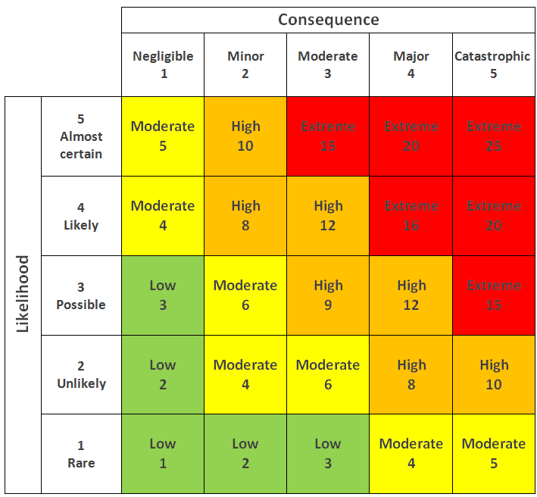

 The learner can use test risk matrix

 Have to write **evaluation** of the impact

 There are many formats to develop test risk matrix in the internet

 Learner can choose any format which is shown for developed project. (Just sample)

|  |  |  |  |  |  |  |
| --- | --- | --- | --- | --- | --- | --- |
| **Risk ID** | **Risk** | **Likelihood**  **(1-5)** | **Consequence**  **(1 – 5)** | **Type of**  **Testing** | **Risk Rating** | **Risk Level** |
| 1 | User can’t login with the registered credential | 3 | 4 | UAT Testing | 12 | High |
| 2 | User can’t reach the website and can’t access any of the functionality | 3 | 4 | UAT Testing | 12 | High |

|  |  |  |  |  |  |  |
| --- | --- | --- | --- | --- | --- | --- |
| 3 | User are not able to post the cars for others to bid | 3 | 4 | UAT Testing | 12 | High |
| 4 | User will not be able to find the expected car | 3 | 3 | UAT Testing | 9 | High |
| 5 | User can’t change their information | 3 | 3 | UAT Testing | 9 | High |
| 6 | User can’t register and can’t login | 3 | 4 | Unit Testing | 12 | High |
| 7 | User will not be able to log in the portal | 3 | 4 | Unit Testing | 12 | High |
| 8 | Users can’t post car to sale on the website | 3 | 4 | Unit Testing | 12 | High |
| 9 | User will not be able to search for any car | 3 | 3 | Unit Testing | 9 | High |
| 10 | User can’t search for a specific car they’re looking for | 3 | 4 | Unit Testing | 12 | High |
| 11 | User will lose interest and will not register to the website | 4 | 4 | Performance Testing | 16 | Extreme |
| 12 | If the users using different browser and the website looks broken there user might lose interest in the website | 3 | 3 | Compatibility Testing | 9 | High |
| 13 | If the users using different browser and the website looks broken there user might lose interest in the website | 3 | 3 | Compatibility Testing | 9 | High |
| 14 | If the users using different browser and the website looks broken there user might lose interest in the website | 3 | 3 | Compatibility Testing | 9 | High |

|  |  |  |  |  |  |  |
| --- | --- | --- | --- | --- | --- | --- |
| 15 | If the users using different browser and the website looks broken there user might lose interest in the website | 3 | 3 | Compatibility Testing | 9 | High |
| 16 | If the users using different browser and the website looks broken there user might lose interest in the website | 3 | 2 | Compatibility Testing | 6 | Moderate |
| 17 | Users may lose interest and select another option if the website is not adaptable to their device of choice | 3 | 4 | Portability Testing | 12 | High |
| 18 | User will get confused and detered from going back to the website | 3 | 4 | Usability Testing | 12 | High |
| 19 | User will get confused and detered from going back to the website | 3 | 4 | Usability Testing | 12 | High |
| 20 | User will get confused and detered from going back to the website | 3 | 4 | Usability Testing | 12 | High |
| 21 | User will get confused and detered from going back to the website | 3 | 4 | Usability Testing | 12 | High |
| 22 | User will get confused and detered from going back to the website | 3 | 3 | Usability Testing | 9 | High |
| 23 | failure could prevent users from accessing the portal. | 3 | 4 | Security Testing | 12 | High |
| 24 | If the users is able to access the administrator only page then all of the data is breached and can caused a lot of problem | 3 | 5 | Security Testing | 12 | Extreme |
| 25 | SQL injection could allow unauthorized access to sensitive information in the database. | 3 | 5 | Security Testing | 15 | Extreme |

***Reference Link:***

https://i-sight.com/resources/risk-assessment-matrix/

<https://www.industrysafe.com/blog/levels-of-a-risk-matrix?hsCtaTracking=5056cd4b-a08a-4fde-a321-009593af2e12%7C9ba9a603-a56c-4213-a16a-253000efc76b>

1. Task 5

Task Statement

Create the following items under “Testing Strategy” in Project Report

1. Design suitable RBT cycle content and priorities further test cycles
2. Communicate the details of the strategy and test planning to the key stakeholders with proper justifications

Solution

**1. Design suitable RBT cycle content and priorities further test cycles.**

Based on your car sale portal project, design and explain a suitable risk base **test cycle.**

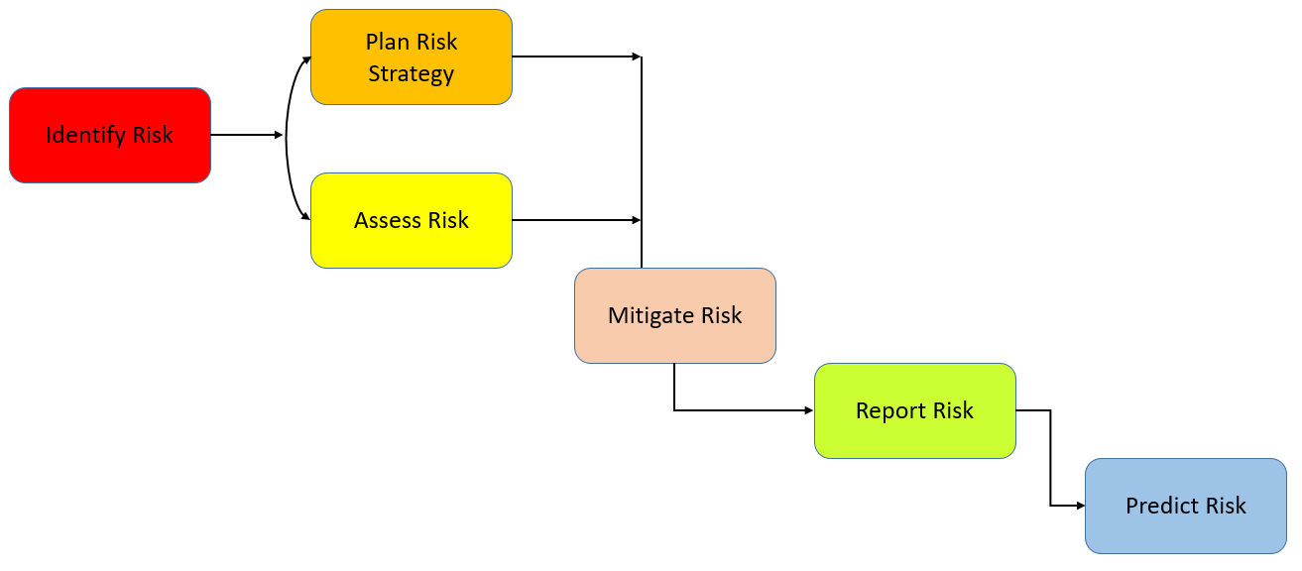

Discuss each of the above stage with detail plan

Identify risk

* Analyze customer requirements for the ABC Car portal clearly
* Consult business and technical staff for information on various risks
* Hold a brainstorming session with the team to gather individual inputs on risk

Plan risk strategy and assess risk

* Create a Risk Register to list identified risks
* Develop a detailed risk assessment plan by filtering risks based on likelihood and significant impact
* Use a Risk Matrix to calculate the risk level and prioritize which risks to test in the test plan
* Design and execute test cases based on risk item priority
* Evaluate the exit criteria to ensure all high-risk items are fully tested, with only minor residual risk remaining

Mitigate risk

* Set up meetings with stakeholders to discuss possible solutions and obtain updates on previously managed risks
* Create a centralized system to record risk data as a reference for future risk management
* Consult with risk analysts or experts to eliminate or contain risks as much as possible

Report risk

* Record the outcome or log of risk-based testing and forward the report to the development team to fix failed test cases

Predict risk

* Predict future risks based on assessed risks and create a contingency plan as a workaround for unforeseen events.

1. Communicate the details of the strategy and test planning to the key stakeholders with proper justifications

* 1. Justify the selection of test methods based on quantified risk to a project.

|  |  |
| --- | --- |
| **Type of Testing** | **Main Purpose** |
| Functional Testing | This testing focuses on validating functions mentioned in project requirement specification for user and admin correspondingly, such as login, register, view car’s details, post new car with details, bidding car’s price. |
| Security Testing | This type of testing aims to identify potential risks and threats to the used car portal, including vulnerabilities, hazards, and malicious attacks that could result in loss of income, data, and reputation. One common type of attack is SQL injection, where an intruder injects malicious SQL statements into an input field, such as the search bar, to gain unauthorized access to and modify the portal's database (WHAT IS SQL INJECTION?, n.d.). If successful, this attack could compromise the confidentiality of user data and expose the portal's database structure, making it more vulnerable to further attacks. To prevent such attacks, Spring Security is used to authenticate and verify users during login and ensure proper authorization based on their roles. |
| Performance testing | The testing concentrates on measuring the performance, agility of the used car portal web pages, like the registration page, to guarantee a more satisfactory user interaction. |
| Compatibility testing | For quality assurance, this testing method checks whether the used car portal can provide a seamless user experience across different web browsers, regardless of the user's preference. It aims to detect and resolve any potential issues with compatibility, such as those that may occur with Chrome, Edge, Firefox, or other popular browsers. |
| Portability testing | The purpose of this testing is to assess the ability of the portal to function effectively on various commercial devices such as smartphones, tablets, and laptops, which is essential for the portal's sustainability and ability to adapt to changing market trends. This requires regular upgrades to the portal to ensure cost savings and maintain high performance. |
| Usability testing | The usability testing assesses the user-friendliness of the used car portal and determines how easy it is for users to interact with portal features to achieve their objectives, such as searching for or posting a car. |

* 1. Communicate the details of your strategy and test planning to the key stakeholders with proper justifications

• Definition of stakeholders

Stakeholders refer to individuals, groups or organizations that can impact or be affected by a software project. They have varying levels of responsibilities and authority throughout the project lifecycle. (Paspelava, 2021)

• Importance of communicating risk to key stakeholders (Jarrad, 2019)

* Promotes accountability: By communicating potential risks to teams and stakeholders, it ensures that roles and responsibilities are assigned to the right people. As a project manager for a used car portal, it is important to identify individuals who can deal with issues to ensure the project stays on track.
* Provides realistic expectations: Transparency in communicating with stakeholders regarding potential risks allows them to have an understanding of how the risk may affect the project timeline. Since stakeholders invest significant finances, transparency can foster more confidence and trust in the project.
* Unifies the team: Effective communication enables the team to respond to risks immediately, avoiding confusion and ensuring a better understanding of potential risks. This approach eliminates the need for an informant as information is shared, and issues can be tackled quickly.

**Task 6**

Create the following items under **“Testing Results”** in Project Report

1. Execute the risk-based test pan and log the test results

2. Modify the risk-based test procedure with the reasons

1 Execute the risk-based test pan and log the test results.

**Execute** the test plan that you define at Task4 (2)

* 1. Test Name, description, risk level, expected and actual results (needs to include)

**Example**

* + 1. Functional Testing (UAT testing)

|  |  |
| --- | --- |
| **Test Scenario** | Registration |
| UA001 |
| **Test Cases** | Registration in ABC CARS PTE LTD Portal |
| UATC001 | Validating data that has entered into registration page |
| UATC002 | Once data has entered it should save the data into database and load thank you page |

|  |  |  |  |  |  |  |
| --- | --- | --- | --- | --- | --- | --- |
| Test Scenario ID | Test Case ID | Test Priority | Pre-condition | Expected Result | Actual Result | Pass/  Fail |
| UA001 | UATC001 | High | ABC Cars Portal website has completed and uploaded on server | After submitting the registration data, will show error email format ‘Please include a ‘@’ in the email address. | Result came out  as expected, | Pass |
| Test Step & Test data | In Registration Page, input test data  1. Name: John doe  2. Email: John@gmail.com  3. Username- john123  4. Password: 12345  5. Click sign up button | | | | | |
| Evidence | **Refer SS- SS01**    Registration succesful    The data is shown in the database | | | | | |

|  |  |
| --- | --- |
| **Test Scenario** | Login |
| UA002 |
| **Test Cases** | Login in ABC CARS PTE LTD Portal |
| UATC001 | Check login validation working correctly |
| UATC002 | Check if the login is working correctly |

|  |  |  |  |  |  |  |
| --- | --- | --- | --- | --- | --- | --- |
| Test Scenario ID | Test Case ID | Test Priority | Pre-condition | Expected Result | Actual Result | Pass/  Fail |
| UA002 | UATC001 | High | ABC Cars Portal website has completed and uploaded on server | After submitting the wrong login data it should not redirect us to the home page | Result came out  as expected, | Pass |
| Test Step & Test data | In Login Page, input test data  Username: John123  Password: thisisnotthepass | | | | | |
| Evidence | The page should return the massage incorrect username or password | | | | | |

|  |  |  |  |  |  |  |
| --- | --- | --- | --- | --- | --- | --- |
| Test Scenario ID | Test Case ID | Test Priority | Pre-condition | Expected Result | Actual Result | Pass/  Fail |
| UA002 | UATC002 | High | ABC Cars Portal website has completed and uploaded on server | After submitting the login data it should redirect us to the home page | Result came out  as expected, | Pass |
| Test Step & Test data | In Login Page, input test data  Username: John123  Password: 12345 | | | | | |
| Evidence | We got redirected to the home page | | | | | |

|  |  |
| --- | --- |
| **Test Scenario** | Post car |
| UA003 |
| **Test Cases** | Posting a car in ABC CARS PTE LTD Portal |
| UATC001 | Check is user can succesfully post a car in the portal |
| UATC002 | Check the validation of empty field |

|  |  |  |  |  |  |  |
| --- | --- | --- | --- | --- | --- | --- |
| Test Scenario ID | Test Case ID | Test Priority | Pre-condition | Expected Result | Actual Result | Pass/  Fail |
| UA003 | UATC001 | High | ABC Cars Portal website has completed and uploaded on server | After submitting the Car information it should return us a message saying that the car is posted | Result came out  as expected, | Pass |
| Test Step & Test data | In Home page click on sell now, input Car data data  Name: BMW  Model: I8  Price: 50000  Make year: 2023  Registration: 2023 | | | | | |
| Evidence | We got a message saying that the car has been successfully posted  Here is the car detail page    Here is the database | | | | | |
| Test Scenario ID | Test Case ID | Test Priority | Pre-condition | Expected Result | Actual Result | Pass/  Fail |
| UA003 | UATC002 | High | ABC Cars Portal website has completed and uploaded on server | After submitting the Car information it should return us a message saying that the car is posted | Result came out  as expected, | Pass |
| Test Step & Test data | In Home page click on sell now, input Car data data  Name: BMW  Model: I8  Price: -  Make year: 2023  Registration: 2023 | | | | | |
| Evidence | We got a popup telling the user to please input the field | | | | | |

|  |  |
| --- | --- |
| **Test Scenario** | Search car |
| UA004 |
| **Test Cases** | Posting a car in ABC CARS PTE LTD Portal |
| UATC001 | Check is user can succesfully search a car in the portal |
| UATC002 | Check if the car detail can be viewed |

|  |  |  |  |  |  |  |
| --- | --- | --- | --- | --- | --- | --- |
| Test Scenario ID | Test Case ID | Test Priority | Pre-condition | Expected Result | Actual Result | Pass/  Fail |
| UA004 | UATC001 | High | ABC Cars Portal website has completed and uploaded on server | After submitting the search bar then you will be redirected to the car you searched for | Result came out  as expected, | Pass |
| Test Step & Test data | In header, input =  Search: I8 | | | | | |
| Evidence | the result: | | | | | |
| Test Scenario ID | Test Case ID | Test Priority | Pre-condition | Expected Result | Actual Result | Pass/  Fail |
| UA004 | UATC002 | High | ABC Cars Portal website has completed and uploaded on server | After submitting the Car information you can click on the view detail to view the cars detail | Result came out  as expected, | Pass |
| Test Step & Test data | In search result page click on car detail | | | | | |
| Evidence | You will be able to see all of the car details | | | | | |

|  |  |
| --- | --- |
| **Test Scenario** | Update profile |
| UA005 |
| **Test Cases** | Updating profile in ABC CARS PTE LTD Portal |
| UATC001 | Check is user can successfully update their profile in the portal |
| UATC002 | Check the validation of blank field |

|  |  |  |  |  |  |  |
| --- | --- | --- | --- | --- | --- | --- |
| Test Scenario ID | Test Case ID | Test Priority | Pre-condition | Expected Result | Actual Result | Pass/  Fail |
| UA005 | UATC001 | High | ABC Cars Portal website has completed and uploaded on server | After updating the user information will be updated both on the page itself and on the database | Result came out  as expected, | Pass |
| Test Step & Test data | In the profile page click on the update button and fill in the form with mobile: 2869128612  Address: Indonesia | | | | | |
| Evidence | Input all of the data  Click on update    The profile has been succesfully updated in the page and in the database | | | | | |
| Test Scenario ID | Test Case ID | Test Priority | Pre-condition | Expected Result | Actual Result | Pass/  Fail |
| UA005 | UATC002 | High | ABC Cars Portal website has completed and uploaded on server | After submitting the update profile they will be forced to input the field that they have missed | Result came out  as expected, | Pass |
| Test Step & Test data | In the profile page click on the update button and fill in the form with mobile: 2869128612  Address: | | | | | |
| Evidence | We got a popup saying that we need to input the data | | | | | |

* + 1. Functional Testing (Unit testing)

|  |  |
| --- | --- |
| **Test Scenario** | Registration |
| TS001 |
| **Test Cases** | Registration in ABC CARS PTE LTD Portal |
| TC001 | Validating data that has entered into registration page |

|  |  |  |  |  |  |  |
| --- | --- | --- | --- | --- | --- | --- |
| Test Scenario ID | Test Case ID | Test Priority | Pre-condition | Expected Result | Actual Result | Pass/  Fail |
| TS001 | TC001 | High | ABC Cars Portal website has completed and uploaded on server | Check if the registered user credentials is saved or not | Result came out  as expected, | Pass |
| Test Step & Test data | Run test script  Name= buto  Username = buto  Email= [buto@gmail.com](mailto:buto@gmail.com)  Password= buto123 | | | | | |
| Evidence |  | | | | | |

|  |  |
| --- | --- |
| **Test Scenario** | Check if user data exist |
| TS002 |
| **Test Cases** | JUNIT |
| TC001 | Validating data that has entered into registration page |

|  |  |  |  |  |  |  |
| --- | --- | --- | --- | --- | --- | --- |
| Test Scenario ID | Test Case ID | Test Priority | Pre-condition | Expected Result | Actual Result | Pass/  Fail |
| TS002 | TC001 | High | ABC Cars Portal website has completed and uploaded on server | JUNIT should return a passing result | Result came out  as expected, | Pass |
| Test Step & Test data | Run test script  Username = Brad | | | | | |
| Evidence | The result: | | | | | |

|  |  |
| --- | --- |
| **Test Scenario** | Check for posting car information |
| TS003 |
| **Test Cases** | JUNIT |
| TC001 | Validate if a car information can be successfully added or not |

|  |  |  |  |  |  |  |
| --- | --- | --- | --- | --- | --- | --- |
| Test Scenario ID | Test Case ID | Test Priority | Pre-condition | Expected Result | Actual Result | Pass/  Fail |
| TS003 | TC001 | High | ABC Cars Portal website has completed and uploaded on server | JUNIT should return a passing result | Result came out  as expected, | Pass |
| Test Step & Test data | Run test script  name = Acura  model= NSX  Price = 50000  Make Year = 2021  Registration Date = 2021 | | | | | |
| Evidence | The result: | | | | | |

|  |  |
| --- | --- |
| **Test Scenario** | Searching a car |
| TS004 |
| **Test Cases** | JUNIT |
| TC001 | Validate can a car be searched or not |

|  |  |  |  |  |  |  |
| --- | --- | --- | --- | --- | --- | --- |
| Test Scenario ID | Test Case ID | Test Priority | Pre-condition | Expected Result | Actual Result | Pass/  Fail |
| TS004 | TC001 | High | ABC Cars Portal website has completed and uploaded on server | JUNIT should return a passing result | Result came out  as expected, | Pass |
| Test Step & Test data | Run test script  Search: Toyota | | | | | |
| Evidence | The result: | | | | | |

|  |  |
| --- | --- |
| **Test Scenario** | Bidding a car |
| TS005 |
| **Test Cases** | JUNIT |
| TC001 | Validate can a car be bid or not |

|  |  |  |  |  |  |  |
| --- | --- | --- | --- | --- | --- | --- |
| Test Scenario ID | Test Case ID | Test Priority | Pre-condition | Expected Result | Actual Result | Pass/  Fail |
| TS005 | TC001 | High | ABC Cars Portal website has completed and uploaded on server | JUNIT should return a passing result | Result came out  as expected, | Pass |
| Test Step & Test data | Run test script  Bidding price = 50000  Car Name = “Audi”  User name = “Romeo” | | | | | |
| Evidence | The result: | | | | | |

* + 1. Performance testing

|  |  |
| --- | --- |
| **Test Scenario** | Test loading speed and performance of the registration page |
| PM001 |
| **Test Cases** | Performance testing |
| PMC001 | Testing the loading page of the registration page using built in chrome devtool |
| PMC002 | To check the performance using lighthouse in Chrome devtool |

|  |  |  |  |  |  |  |
| --- | --- | --- | --- | --- | --- | --- |
| Test Scenario ID | Test Case ID | Test Priority | Pre-condition | Expected Result | Actual Result | Pass/  Fail |
| PM001 | PMC001 | High | ABC Cars Portal website has completed and uploaded on server | The loading spped should meet the expected performance standard | Result came out  as expected, | Pass |
| Test Step & Test data | 1.Use Chrome DevTools by pressing ctrl + shift + I in your keyboard  2.Click Network, choose No throttling, Fast 3G, Slow 3G  3. Click “Register” on website navigation bar | | | | | |
| Evidence | **No throthling**    For no throthling the result is a finish time of 136ms which is good  **Slow 3G**  For slow 3g the loat time is 6.44s which is not bad  **Fast 3G** | | | | | |

|  |  |  |  |  |  |  |
| --- | --- | --- | --- | --- | --- | --- |
| Test Scenario ID | Test Case ID | Test Priority | Pre-condition | Expected Result | Actual Result | Pass/  Fail |
| PM001 | PMC002 | High | ABC Cars Portal website has completed and uploaded on server | The performance should meet the expected performance standard | Result came out  as expected, | Pass |
| Test Step & Test data | 1.Use Chrome DevTools by pressing ctrl + shift + I in your keyboard  2.Click lighthouse  3. Click “Analyze page load” on website navigation bar | | | | | |
| Evidence | **The test results came out perfectly at 100** | | | | | |

* + 1. Compatibility testing

|  |  |
| --- | --- |
| **Test Scenario** | Consistent look and feel of the registration page |
| CB001 |
| **Test Cases** | Cross browser testing |
| CBC001 | To ensure the look and feel of the registration page across different browsers (chrome) |
| CBC002 | To ensure the look and feel of the registration page across different browsers (Firefox) |
| CBC003 | To ensure the look and feel of the registration page across different browsers (Edge) |

|  |  |  |  |  |  |  |
| --- | --- | --- | --- | --- | --- | --- |
| Test Scenario ID | Test Case ID | Test Priority | Pre-condition | Expected Result | Actual Result | Pass/  Fail |
| CB001 | CBC001 | High | ABC Cars Portal website has completed and uploaded on server | The look and feel of the registration page should be the same across all 3 browser | Result came out  as expected, | Pass |
| Test Step & Test data | 1. Download ngrok for windows and add authtoken to terminal, enter ngrok http 1010  2. Paste forwarding URL in Lambdatest.com  3. Click ‘Register’ | | | | | |
| Evidence | **The look and feel of the website is the same in chrome** | | | | | |

|  |  |  |  |  |  |  |
| --- | --- | --- | --- | --- | --- | --- |
| Test Scenario ID | Test Case ID | Test Priority | Pre-condition | Expected Result | Actual Result | Pass/  Fail |
| CB001 | CBC002 | High | ABC Cars Portal website has completed and uploaded on server | The look and feel of the registration page should be the same across all 3 browser | Result came out  as expected, | Pass |
| Test Step & Test data | 1. Download ngrok for windows and add authtoken to terminal, enter ngrok http 1010  2. Paste forwarding URL in Lambdatest.com  3. Click ‘Register’ | | | | | |
| Evidence | **The look and feel of the website is the same in Firefox** | | | | | |

|  |  |  |  |  |  |  |
| --- | --- | --- | --- | --- | --- | --- |
| Test Scenario ID | Test Case ID | Test Priority | Pre-condition | Expected Result | Actual Result | Pass/  Fail |
| CB001 | CBC003 | High | ABC Cars Portal website has completed and uploaded on server | The look and feel of the registration page should be the same across all 3 browser | Result came out  as expected, | Pass |
| Test Step & Test data | 1. Download ngrok for windows and add authtoken to terminal, enter ngrok http 1010  2. Paste forwarding URL in Lambdatest.com  3. Click ‘Register’ | | | | | |
| Evidence | **The look and feel of the website is the same in Edge** | | | | | |

|  |  |
| --- | --- |
| **Test Scenario** | Consistent look and feel of the Login page |
| CB002 |
| **Test Cases** | Cross browser testing |
| CBC001 | To ensure the look and feel of the Login page across different browsers (chrome) |
| CBC002 | To ensure the look and feel of the Login page across different browsers (Firefox) |
| CBC003 | To ensure the look and feel of the Login page across different browsers (Edge) |

|  |  |  |  |  |  |  |
| --- | --- | --- | --- | --- | --- | --- |
| Test Scenario ID | Test Case ID | Test Priority | Pre-condition | Expected Result | Actual Result | Pass/  Fail |
| CB002 | CBC001 | High | ABC Cars Portal website has completed and uploaded on server | The look and feel of the login page should be the same across all 3 browser | Result came out  as expected, | Pass |
| Test Step & Test data | 1. Download ngrok for windows and add authtoken to terminal, enter ngrok http 1010  2. Paste forwarding URL in Lambdatest.com  3. Click ‘Login’ | | | | | |
| Evidence | **The look and feel of the website is the same in chrome** | | | | | |
| Test Scenario ID | Test Case ID | Test Priority | Pre-condition | Expected Result | Actual Result | Pass/  Fail |
| CB002 | CBC002 | High | ABC Cars Portal website has completed and uploaded on server | The look and feel of the Login page should be the same across all 3 browser | Result came out  as expected, | Pass |
| Test Step & Test data | 1. Download ngrok for windows and add authtoken to terminal, enter ngrok http 1010  2. Paste forwarding URL in Lambdatest.com  3. Click ‘login’ | | | | | |
| Evidence | **The look and feel of the website is the same in Firefox** | | | | | |

|  |  |  |  |  |  |  |
| --- | --- | --- | --- | --- | --- | --- |
| Test Scenario ID | Test Case ID | Test Priority | Pre-condition | Expected Result | Actual Result | Pass/  Fail |
| CB002 | CBC003 | High | ABC Cars Portal website has completed and uploaded on server | The look and feel of the Login page should be the same across all 3 browser | Result came out  as expected, | Pass |
| Test Step & Test data | 1. Download ngrok for windows and add authtoken to terminal, enter ngrok http 1010  2. Paste forwarding URL in Lambdatest.com  3. Click ‘login | | | | | |
| Evidence | **The look and feel of the website is the same in Edge** | | | | | |
| Test Scenario | Consistent look and feel of the Home page | | | | | |
| CB003 |
| Test Cases | Cross browser testing | | | | | |
| CBC001 | To ensure the look and feel of the Home page across different browsers (chrome) | | | | | |
| CBC002 | To ensure the look and feel of the Home page across different browsers (Firefox) | | | | | |
| CBC003 | To ensure the look and feel of the Home page across different browsers (Edge) | | | | | |

|  |  |  |  |  |  |  |
| --- | --- | --- | --- | --- | --- | --- |
| Test Scenario ID | Test Case ID | Test Priority | Pre-condition | Expected Result | Actual Result | Pass/  Fail |
| CB003 | CBC001 | High | ABC Cars Portal website has completed and uploaded on server | The look and feel of the Home page should be the same across all 3 browser | Result came out  as expected, | Pass |
| Test Step & Test data | 1. Download ngrok for windows and add authtoken to terminal, enter ngrok http 1010  2. Paste forwarding URL in Lambdatest.com  3. Click ‘Login’ | | | | | |
| Evidence | **The look and feel of the website is the same in chrome** | | | | | |
| Test Scenario ID | Test Case ID | Test Priority | Pre-condition | Expected Result | Actual Result | Pass/  Fail |
| CB003 | CBC002 | High | ABC Cars Portal website has completed and uploaded on server | The look and feel of the home page should be the same across all 3 browser | Result came out  as expected, | Pass |
| Test Step & Test data | 1. Download ngrok for windows and add authtoken to terminal, enter ngrok http 1010  2. Paste forwarding URL in Lambdatest.com  3. login | | | | | |
| Evidence | **The look and feel of the website is the same in Firefox** | | | | | |

|  |  |  |  |  |  |  |
| --- | --- | --- | --- | --- | --- | --- |
| Test Scenario ID | Test Case ID | Test Priority | Pre-condition | Expected Result | Actual Result | Pass/  Fail |
| CB003 | CBC003 | High | ABC Cars Portal website has completed and uploaded on server | The look and feel of the registration page should be the same across all 3 browser | Result came out  as expected, | Pass |
| Test Step & Test data | 1. Download ngrok for windows and add authtoken to terminal, enter ngrok http 1010  2. Paste forwarding URL in Lambdatest.com  3. login | | | | | |
| Evidence | **The look and feel of the website is the same in Edge** | | | | | |
| Test Scenario | Consistent look and feel of the Car Detail page | | | | | |
| CB004 |
| Test Cases | Cross browser testing | | | | | |
| CBC001 | To ensure the look and feel of the Car detail page across different browsers (chrome) | | | | | |
| CBC002 | To ensure the look and feel of the Car detail page across different browsers (Firefox) | | | | | |
| CBC003 | To ensure the look and feel of the Car detail page across different browsers (Edge) | | | | | |

|  |  |  |  |  |  |  |
| --- | --- | --- | --- | --- | --- | --- |
| Test Scenario ID | Test Case ID | Test Priority | Pre-condition | Expected Result | Actual Result | Pass/  Fail |
| CB004 | CBC001 | High | ABC Cars Portal website has completed and uploaded on server | The look and feel of the Car detail page should be the same across all 3 browser | Result came out  as expected, | Pass |
| Test Step & Test data | 1. Download ngrok for windows and add authtoken to terminal, enter ngrok http 1010  2. Paste forwarding URL in Lambdatest.com  3. Click ‘View car details’ | | | | | |
| Evidence | **The look and feel of the website is the same in chrome** | | | | | |
| Test Scenario ID | Test Case ID | Test Priority | Pre-condition | Expected Result | Actual Result | Pass/  Fail |
| CB004 | CBC002 | High | ABC Cars Portal website has completed and uploaded on server | The look and feel of the Car detail page should be the same across all 3 browser | Result came out  as expected, | Pass |
| Test Step & Test data | 1. Download ngrok for windows and add authtoken to terminal, enter ngrok http 1010  2. Paste forwarding URL in Lambdatest.com  3. Click ‘View car details’ | | | | | |
| Evidence | **The look and feel of the website is the same in Firefox** | | | | | |

|  |  |  |  |  |  |  |
| --- | --- | --- | --- | --- | --- | --- |
| Test Scenario ID | Test Case ID | Test Priority | Pre-condition | Expected Result | Actual Result | Pass/  Fail |
| CB004 | CBC003 | High | ABC Cars Portal website has completed and uploaded on server | The look and feel of the Car detail page should be the same across all 3 browser | Result came out  as expected, | Pass |
| Test Step & Test data | 1. Download ngrok for windows and add authtoken to terminal, enter ngrok http 1010  2. Paste forwarding URL in Lambdatest.com  3. Click ‘View car details’ | | | | | |
| Evidence | **The look and feel of the website is the same in Edge** | | | | | |

|  |  |
| --- | --- |
| **Test Scenario** | Consistent look and feel of the Profile page |
| CB005 |
| **Test Cases** | Cross browser testing |
| CBC001 | To ensure the look and feel of the Profile page across different browsers (chrome) |
| CBC002 | To ensure the look and feel of the Profile page across different browsers (Firefox) |
| CBC003 | To ensure the look and feel of the Profile page across different browsers (Edge) |

|  |  |  |  |  |  |  |
| --- | --- | --- | --- | --- | --- | --- |
| Test Scenario ID | Test Case ID | Test Priority | Pre-condition | Expected Result | Actual Result | Pass/  Fail |
| CB005 | CBC001 | High | ABC Cars Portal website has completed and uploaded on server | The look and feel of the Profile page should be the same across all 3 browser | Result came out  as expected, | Pass |
| Test Step & Test data | 1. Download ngrok for windows and add authtoken to terminal, enter ngrok http 1010  2. Paste forwarding URL in Lambdatest.com  3. Click ‘profile | | | | | |
| Evidence | **The look and feel of the website is the same in chrome** | | | | | |
| Test Scenario ID | Test Case ID | Test Priority | Pre-condition | Expected Result | Actual Result | Pass/  Fail |
| CB003 | CBC002 | High | ABC Cars Portal website has completed and uploaded on server | The look and feel of the Profile page should be the same across all 3 browser | Result came out  as expected, | Pass |
| Test Step & Test data | 1. Download ngrok for windows and add authtoken to terminal, enter ngrok http 1010  2. Paste forwarding URL in Lambdatest.com  3. Click ‘Profile’ | | | | | |
| Evidence | **The look and feel of the website is the same in Firefox** | | | | | |

|  |  |  |  |  |  |  |
| --- | --- | --- | --- | --- | --- | --- |
| Test Scenario ID | Test Case ID | Test Priority | Pre-condition | Expected Result | Actual Result | Pass/  Fail |
| CB005 | CBC003 | High | ABC Cars Portal website has completed and uploaded on server | The look and feel of the profile page should be the same across all 3 browser | Result came out  as expected, | Pass |
| Test Step & Test data | 1. Download ngrok for windows and add authtoken to terminal, enter ngrok http 1010  2. Paste forwarding URL in Lambdatest.com  3. Click ‘Profile’ | | | | | |
| Evidence | **The look and feel of the website is the same in Edge** | | | | | |

* + 1. Portability testing

|  |  |
| --- | --- |
| **Test Scenario** | Consistent look and feel of the registration page |
| PB001 |
| **Test Cases** | Portability testing |
| PBC001 | To ensure the look and feel of the registration page across different devices (laptop) |
| PBC002 | To ensure the look and feel of the registration page across different Devices (Ipad) |
| PBC003 | To ensure the look and feel of the registration page across different Devices (Phone) |

|  |  |  |  |  |  |  |
| --- | --- | --- | --- | --- | --- | --- |
| Test Scenario ID | Test Case ID | Test Priority | Pre-condition | Expected Result | Actual Result | Pass/  Fail |
| PB001 | PBC001 | High | ABC Cars Portal website has completed and uploaded on server | The look and feel of the Registration page should be the same across all 3 Devices | Result came out  as expected, | pass |
| Test Step & Test data | * Click on ctrl shift I for inspect * Click on the top of the screen * Choose the corresponding devices | | | | | |
| Evidence | **I designed it while looking at a monitor screen so the results will be the best for a laptop** | | | | | |

|  |  |  |  |  |  |  |
| --- | --- | --- | --- | --- | --- | --- |
| Test Scenario ID | Test Case ID | Test Priority | Pre-condition | Expected Result | Actual Result | Pass/  Fail |
| PB001 | PBC002 | High | ABC Cars Portal website has completed and uploaded on server | The look and feel of the Registration page should be the same across all 3 Devices | Result came out  Not as expected, | Fail |
| Test Step & Test data | * Click on ctrl shift I for inspect * Click on the top of the screen * Choose the corresponding devices | | | | | |
| Evidence | **The navbar for the ipad screen is not showing** | | | | | |

|  |  |  |  |  |  |  |
| --- | --- | --- | --- | --- | --- | --- |
| Test Scenario ID | Test Case ID | Test Priority | Pre-condition | Expected Result | Actual Result | Pass/  Fail |
| PB001 | PBC003 | High | ABC Cars Portal website has completed and uploaded on server | The look and feel of the Registration page should be the same across all 3 Devices | Result came out  Not as expected, | Fail |
| Test Step & Test data | * Click on ctrl shift I for inspect * Click on the top of the screen * Choose the corresponding devices | | | | | |
| Evidence | **The navbar for the Phone screen is not showing** | | | | | |

* + 1. Portability testing

|  |  |
| --- | --- |
| **Test Scenario** | Evaluate the user friendliness of the registration page |
| UB001 |
| **Test Cases** | Usability Testing |
| UBC001 | To ensure all of the buttons header, footer and all of the functionality works in the registration page |

|  |  |  |  |  |  |  |
| --- | --- | --- | --- | --- | --- | --- |
| Test Scenario ID | Test Case ID | Test Priority | Pre-condition | Expected Result | Actual Result | Pass/  Fail |
| UB001 | UBC001 | High | ABC Cars Portal website has completed and uploaded on server | All of the links in the register page is working intently with clear flow for the usability for the user | Result came out  as expected, | Pass |
| Test Step & Test data | * Open localhost:1010 * Click register | | | | | |
| Evidence | **The feature of the Registration page is all working correctly** | | | | | |

|  |  |
| --- | --- |
| **Test Scenario** | Evaluate the user friendliness of the login page |
| UB002 |
| **Test Cases** | Usability Testing |
| UBC001 | To ensure all of the buttons header, footer and all of the functionality works in the login page |

|  |  |  |  |  |  |  |
| --- | --- | --- | --- | --- | --- | --- |
| Test Scenario ID | Test Case ID | Test Priority | Pre-condition | Expected Result | Actual Result | Pass/  Fail |
| UB002 | UBC001 | High | ABC Cars Portal website has completed and uploaded on server | All of the links in the register page is working intently with clear flow for the usability for the user | Result came out  as expected, | Pass |
| Test Step & Test data | * Open localhost:1010 * Click login | | | | | |
| Evidence | **The feature of the login page is all working correctly** | | | | | |

|  |  |
| --- | --- |
| **Test Scenario** | Evaluate the user friendliness of the Home page |
| UB003 |
| **Test Cases** | Usability Testing |
| UBC001 | To ensure all of the buttons header, footer and all of the functionality works in the Home page |

|  |  |  |  |  |  |  |
| --- | --- | --- | --- | --- | --- | --- |
| Test Scenario ID | Test Case ID | Test Priority | Pre-condition | Expected Result | Actual Result | Pass/  Fail |
| UB003 | UBC001 | High | ABC Cars Portal website has completed and uploaded on server | All of the links in the register page is working intently with clear flow for the usability for the user | Result came out  as expected, | Pass |
| Test Step & Test data | * Open localhost:1010 * Login to the website | | | | | |
| Evidence | **The feature of the Home page is all working correctly** | | | | | |

|  |  |
| --- | --- |
| **Test Scenario** | Evaluate the user friendliness of the Car detail page |
| UB004 |
| **Test Cases** | Usability Testing |
| UBC001 | To ensure all of the buttons header, footer and all of the functionality works in the Car detail page |

|  |  |  |  |  |  |  |
| --- | --- | --- | --- | --- | --- | --- |
| Test Scenario ID | Test Case ID | Test Priority | Pre-condition | Expected Result | Actual Result | Pass/  Fail |
| UB004 | UBC001 | High | ABC Cars Portal website has completed and uploaded on server | All of the links in the Car detail page is working intently with clear flow for the usability for the user | Result came out  as expected, | Pass |
| Test Step & Test data | * Open localhost:1010 * Login to the website * Click on view car detail | | | | | |
| Evidence | **The feature of the Car detail page is all working correctly** | | | | | |

|  |  |
| --- | --- |
| **Test Scenario** | Evaluate the user friendliness of the profile page |
| UB005 |
| **Test Cases** | Usability Testing |
| UBC001 | To ensure all of the buttons header, footer and all of the functionality works in the profile page |

|  |  |  |  |  |  |  |
| --- | --- | --- | --- | --- | --- | --- |
| Test Scenario ID | Test Case ID | Test Priority | Pre-condition | Expected Result | Actual Result | Pass/  Fail |
| UB005 | UBC001 | High | ABC Cars Portal website has completed and uploaded on server | All of the links in the profile page is working intently with clear flow for the usability for the user | Result came out  as expected, | Pass |
| Test Step & Test data | * Open localhost:1010 * Click profile | | | | | |
| Evidence | **The feature of the Profile page is all working correctly** | | | | | |

* + 1. Security testing

|  |  |
| --- | --- |
| **Test Scenario** | Verify correct authentication of users after logging in |
| SE001 |
| **Test Cases** | Security Testing |
| SEC001 | To ensure the sec auth for the page for users |
| SEC002 | To ensure the sec auth for the page for Administrator |

|  |  |  |  |  |  |  |
| --- | --- | --- | --- | --- | --- | --- |
| Test Scenario ID | Test Case ID | Test Priority | Pre-condition | Expected Result | Actual Result | Pass/  Fail |
| SE001 | SEC001 | High | ABC Cars Portal website has completed and uploaded on server | User will see the sell now button | Result came out  as expected, | Pass |
| Test Step & Test data | * Open localhost:1010 * Sign in | | | | | |
| Evidence |  | | | | | |

|  |  |  |  |  |  |  |
| --- | --- | --- | --- | --- | --- | --- |
| Test Scenario ID | Test Case ID | Test Priority | Pre-condition | Expected Result | Actual Result | Pass/  Fail |
| SE001 | SEC002 | High | ABC Cars Portal website has completed and uploaded on server | Admin can’t see the sell now button | Result came out  as expected, | Pass |
| Test Step & Test data | * Open localhost:1010 * Sign in as admin | | | | | |
| Evidence |  | | | | | |

|  |  |
| --- | --- |
| **Test Scenario** | Verify correct authentication of users in the header after logging in |
| SE002 |
| **Test Cases** | Security Testing |
| SEC001 | To ensure the sec auth for the header for users |
| SEC002 | To ensure the sec auth for the header for Administrator |

|  |  |  |  |  |  |  |
| --- | --- | --- | --- | --- | --- | --- |
| Test Scenario ID | Test Case ID | Test Priority | Pre-condition | Expected Result | Actual Result | Pass/  Fail |
| SE001 | SEC001 | High | ABC Cars Portal website has completed and uploaded on server | User can only see what is meant to be seen by the user in the header | Result came out  as expected, | Pass |
| Test Step & Test data | * Open localhost:1010 * Sign in as user | | | | | |
| Evidence |  | | | | | |

|  |  |  |  |  |  |  |
| --- | --- | --- | --- | --- | --- | --- |
| Test Scenario ID | Test Case ID | Test Priority | Pre-condition | Expected Result | Actual Result | Pass/  Fail |
| SE002 | SEC002 | High | ABC Cars Portal website has completed and uploaded on server | Admin can see management navigation | Result came out  as expected, | Pass |
| Test Step & Test data | * Open localhost:1010 * Sign in as Admin | | | | | |
| Evidence |  | | | | | |

|  |  |
| --- | --- |
| **Test Scenario** | SQL Injection |
| SE003 |
| **Test Cases** | Security Testing |
| SEC001 | To ensure the website is free from sql injection attacks |

|  |  |  |  |  |  |  |
| --- | --- | --- | --- | --- | --- | --- |
| Test Scenario ID | Test Case ID | Test Priority | Pre-condition | Expected Result | Actual Result | Pass/  Fail |
| SE003 | SEC001 | High | ABC Cars Portal website has completed and uploaded on server | No return given from the injected sql queries | Result came out  as expected, | Pass |
| Test Step & Test data | * Open localhost:1010 * Sign in to the portal * Navigate to home page navigation bar, search bar * Enter search input * Click Search  Search input = Select * from car | | | | | |
| Evidence |  | | | | | |

**Provide a detailed log of test results**

Show in tabular format with (test Name, comments, description, test result, start time, end time)

|  |  |
| --- | --- |
|  | **Used Car Sale Portal Project** |
|  |  |
| **Reported By:** | Darren Farrell |
| **Report Date:** | 7/5/2023 |
|  |  |
| **Tested By:** | Darren Farrell |
| **Tested Date:** | 12/7/2022 |
| **Testing Name/ Test Scenario ID** | Functional testing:-UAT Testing/ TS001 / TS002 / TS003 / TS004 /TS005 |
| **Total Number of Test Cases** | 5 |
| **No. of Pass:** | 5 |
| **No. of Failures:** | 0 |
| **Elapsed Time:** | 00:45:00 |
|  |  |
| **Tested By:** | Darren Farrell |
| **Tested Date:** | 7/5/2023 |
| **Testing Name/ Test Scenario ID** | Functional testing:- Unit Testing/ TS001 / TS002 / TS003 / TS004 /TS005 |
| **Total Number of Test Cases** | 5 |
| **No. of Pass:** | 5 |
| **No. of Failures:** | 0 |
| **Elapsed Time:** | 00:45:00 |
|  |  |
| **Tested By:** | Darren Farrell |
| **Tested Date:** | 7/5/2023 |
| **Testing Name/ Test Scenario ID** | Performance Testing/ PM001 |
| **Total Number of Test Cases** | 2 |
| **No. of Pass:** | 2 |
| **No. of Failures:** | 0 |
| **Elapsed Time:** | 00:10:00 |
|  |  |
| **Tested By:** | Darren Farrell |
| **Tested Date:** | 7/5/2023 |
| **Testing Name/ Test Scenario ID** | Compatibility Testing/ CB001 / CB002 / CB003 / CB004 / CB005 |
| **Total Number of Test Cases** | 15 |
| **No. of Pass:** | 15 |
| **No. of Failures:** | 0 |
| **Elapsed Time:** | 01:00:00 |
|  |  |
| **Tested By:** | Darren Farrell |
| **Tested Date:** | 7/5/2023 |
| **Testing Name/ Test Scenario ID** | Usability Testing/ UB001/ UB002/UB003/UB004/UB005 |
| **Total Number of Test Cases** | 5 |
| **No. of Pass:** | 5 |
| **No. of Failures:** | 0 |
| **Elapsed Time:** | 00:20:00 |
|  |  |
| **Tested By:** | Darren Farrell |
| **Tested Date:** | 7/5/2023 |
| **Testing Name/ Test Scenario ID** | Security Testing/ SE001/ SE002/ SE003 |
| **Total Number of Test Cases** | 5 |
| **No. of Pass:** | 5 |
| **No. of Failures:** | 0 |
| **Elapsed Time:** | 00:25:00 |
|  |  |
| **Tested By:** | Darren Farrell |
| **Tested Date:** | 7/5/2023 |
| **Testing Name/ Test Scenario ID** | Portability Testing/ PB001 |
| **Total Number of Test Cases** | 3 |
| **No. of Pass:** | 1 |
| **No. of Failures:** | 2 |
| **Elapsed Time:** | 00:20:00 |
| **SUMMARY LOG STATUS** | |
| **Total Number of Test Cases** | 45 |
| **Total Number of Pass** | 43 |
| **Total Number of Failures** | 2 |
| **Pass %** | 95,56% |
| **Total Elapsed Time** | 3:45:00 |

2. Modify the risk-based test procedure with the reasons

According to Log Result, you need to modify RBT strategy on car portal project.

1. Identify Risk upon Log Fail Result

2. Identify Impacts upon it.

3. Modify RBT test plan along with Prioritization

4. Create RBT test plan with test scenario, test cases, and prioritization

5. Modify if the code is needed

6. Execute test cases

7. Create a test log report again (like above)

Here are the failed test results

|  |  |  |  |  |  |  |
| --- | --- | --- | --- | --- | --- | --- |
| Test Scenario ID | Test Case ID | Test Priority | Pre-condition | Expected Result | Actual Result | Pass/  Fail |
| PB001 | PBC002 | High | ABC Cars Portal website has completed and uploaded on server | The look and feel of the Registration page should be the same across all 3 Devices | Result came out  Not as expected, | Fail |
| Test Step & Test data | * Click on ctrl shift I for inspect * Click on the top of the screen * Choose the corresponding devices | | | | | |
| Evidence | **The navbar for the ipad screen is not showing** | | | | | |

|  |  |  |  |  |  |  |
| --- | --- | --- | --- | --- | --- | --- |
| Test Scenario ID | Test Case ID | Test Priority | Pre-condition | Expected Result | Actual Result | Pass/  Fail |
| PB001 | PBC003 | High | ABC Cars Portal website has completed and uploaded on server | The look and feel of the Registration page should be the same across all 3 Devices | Result came out  Not as expected, | Fail |
| Test Step & Test data | * Click on ctrl shift I for inspect * Click on the top of the screen * Choose the corresponding devices | | | | | |
| Evidence | **The navbar for the Phone screen is not showing** | | | | | |

Modification to the source code for the failed test cases

Add javascript library

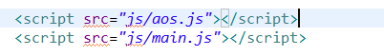

And icon



Write the javascript

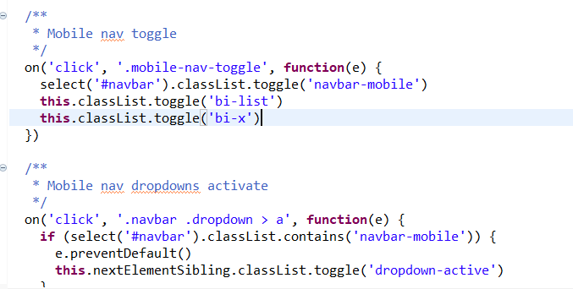

|  |  |  |  |  |  |  |
| --- | --- | --- | --- | --- | --- | --- |
| Test Scenario ID | Test Case ID | Test Priority | Pre-condition | Expected Result | Actual Result | Pass/  Fail |
| PB001 | PBC002 | High | ABC Cars Portal website has completed and uploaded on server | The look and feel of the Registration page should be the same across all 3 Devices | Result came out  Not as expected, | Pass |
| Test Step & Test data | * Click on ctrl shift I for inspect * Click on the top of the screen * Choose the corresponding devices | | | | | |
| Evidence | **The navbar for the ipad screen is showing** | | | | | |

|  |  |  |  |  |  |  |
| --- | --- | --- | --- | --- | --- | --- |
| Test Scenario ID | Test Case ID | Test Priority | Pre-condition | Expected Result | Actual Result | Pass/  Fail |
| PB001 | PBC003 | High | ABC Cars Portal website has completed and uploaded on server | The look and feel of the Registration page should be the same across all 3 Devices | Result came out  Not as expected, | Pass |
| Test Step & Test data | * Click on ctrl shift I for inspect * Click on the top of the screen * Choose the corresponding devices | | | | | |
| Evidence | **The navbar for the Phone screen is showing** | | | | | |

Log Result after modification

|  |  |
| --- | --- |
| **Project ID/ Project Name:** | **Used Car Sale Portal Project** |
|  |  |
| **Reported By:** | Darren Farrell |
| **Report Date:** | 8/5/2023 |
|  |  |
| **Tested By:** | Darren Farrell |
| **Tested Date:** | 8/5/2023 |
| **Testing Name/ Test Scenario ID** | Portability Testing/ PB001 |
| **Total Number of Test Cases** | 2 |
| **No. of Pass:** | 2 |
| **No. of Failures:** | 0 |
| **Elapsed Time:** | 00:10:00 |
|  |  |
| **SUMMARY LOG STATUS** | |
| **Total Number of Test Cases** | 2 |
| **Total Number of Pass** | 2 |
| **Total Number of Failures** | 0 |
| **Pass %** | 100% |
| **Total Elapsed Time** | 00:10:00 |

**Task 7**

Create the following items under **“Evaluation of Testing strategy”** in Project Presentation

1. Evaluate the effectiveness of the RBT strategy and assess the security testing cycles

2. Evaluate the testing strategies and compare it’s pro and cons

3. Assess the importance and environment suitability and examine the test heuristics are identified with proper justification

**1. Evaluate the effectiveness of the RBT strategy and assess the security testing cycles.**

- The use of Risk Based Testing (RBT) has been found to be highly effective in identifying potential flaws in software applications throughout the Software Development Life Cycle (SDLC) model and Spiral model. This is because it allows for the early detection and mitigation of potential risks, reducing the overall negative impact to users and businesses. The first step in RBT is to identify potential risks, which are then assessed using a Risk Matrix to prioritize them based on their level of risk. The highest-risk issues are then prioritized for testing, with test cases planned and documented in a test log. If any test cases fail, a mitigation plan is put in place and the test cases are re-executed until all key risk areas are addressed or risks are maintained at an acceptable level. This cycle is repeated until the customer is satisfied.

- Security testing is also an important aspect of the SDLC model, with security considered a non-functional requirement during the requirement stage. This is because security is essential to the quality of the software product, particularly for a car portal which must be developed with confidentiality and integrity in mind to protect against cyber-attacks. Spring Security is used in the car portal to provide authentication, authorization, and protection against common attacks like SQL injection. Authentication is implemented by verifying a user's identity based on their registered credentials, while authorization is implemented to segregate tasks based on assigned roles. To test for SQL injection, an SQL query is inserted into the input field for searching, and if successful, sensitive data can be exploited and modified. To prevent SQL injection, input validation is included to sanitize input data from malicious code elements.

**2. Evaluate the testing strategies and compare it’s pro and cons**

* 1. The leaner needs to evaluate testing strategies that used in car portal and compare their pro and cons.

<You may compare before using RBT and after using RBT pros and cons>

|  |  |
| --- | --- |
| **Before Using RBT** | |
| **Pro** | **Cons** |
| * Early detection of defects: RBT helps identify potential risks at an early stage of the SDLC, allowing for timely mitigation of the risks. This helps to prevent costly defects from surfacing later in the development cycle or after deployment. | * Subjective approach: RBT relies on human judgment to assess risks, which can be subjective. This may lead to different interpretations of risk levels and inconsistent prioritization of testing efforts. |
| * Efficient use of resources: RBT allows testing teams to focus on high-risk areas first, reducing the number of test cases and resources required. This ensures that testing efforts are focused where they are needed the most, saving both time and money. | * Time-consuming: RBT requires time and effort to assess risks, categorize them, and prioritize them for testing. This can be time-consuming, especially in larger projects. |
| * Increased test coverage: RBT helps ensure that all high-risk areas are covered during testing, which leads to increased test coverage and better test results. | * Incomplete coverage: RBT may miss some risks if they are not identified during the risk assessment phase. This can lead to incomplete coverage of the application under test, which can result in undetected defects. |

**3. Assess the importance and environment suitability and examine the test heuristics are identified with proper justification**

* 1. Discuss & assess the importance of suitable test environments that need to design and build.
  2. Show how it supports the risk-based test strategy.
  3. The learner needs to write from their perspective.

|  |  |
| --- | --- |
| **Environment** | **The Importance of Environment Suitability and How It Supports RBT Test Strategy** |
| STS IDE | The Spring Tool Suite is a widely used integrated development environment (IDE) utilized for creating Spring Boot applications like the ABC Car Portal. Its use in the development of the car portal allows for the application of various features such as dependency injection and robust database transaction management. The IDE also enables the execution of unit tests with the incorporation of JUnit into the build path of the car portal project. In addition, the Spring Boot Test is an essential maven dependency used in conducting unit tests, providing support for mocking and focusing solely on the code to be tested without the involvement of external dependencies or behavior. |
| MySQL Database | The storage of the car portal's user, car, car bidding, and user role information in separate tables is a crucial task, accomplished by the MySQL database. This database is highly secure, providing a range of security features like Firewall, Encryption, and User Authentication. When a user registers on the portal, their password is encrypted and saved in the database, ensuring robust data protection. |
| Window 10 OS | This is the standard operating system that most people have I think. This is one of the most famous operating system. I use this operating system during the development of this project. |
| Java Version 8 | The ABC Car Portal was developed using Java programming language. Java has built-in security features, such as access modifiers, that can control access to fields, methods, and classes. The car portal uses private fields in its POJO classes, which require getter and setter methods to access. Additionally, Java has automatic memory management that relieves developers from the burden of manually managing garbage collection and memory. |
| ABC Cars Pte Ltd  (Used Car Sales Portal Application) | The development of the ABC car portal must be done according to the client's specifications and within the given timeline. The full implementation of the portal involves multiple tests for functional and non-functional requirements. Different types of tests such as unit testing, user acceptance testing (UAT), performance testing, compatibility testing, portability testing, usability testing, and security testing are conducted on the portal. |
| Test Plan | The prioritization of the test plan is determined by the identified risk level using the Risk Matrix. The most severe risks will be addressed first and recorded in a test log. If a test case fails, it will be retested after the issue is resolved. This approach ensures that risks are constantly monitored and the car portal application is of high quality. |
| Documentation | The car portal application maintains a detailed test log that documents the results of various tests, including unit testing, user acceptance testing, performance testing, compatibility testing, portability testing, usability testing, and security testing. By documenting the failed test cases, the risk level can be assessed to identify the most significant risks for re-testing. |
| Devices | During the portability testing phase, the car website was tested for compatibility with various hardware devices, including laptops, tablets/iPads, and mobile phones. Chrome DevTools was used to conduct the portability tests, which involved selecting the Toggle Device toolbar. |
| Browsers | To ensure consistency in appearance and user experience, cross-browser testing was performed using three different browsers: Chrome, Edge, and Firefox on the Lambdatest website. Google Chrome, the primary browser used during development, was also utilized for performance testing using Chrome DevTools and Lighthouse. The goal was to assess the car portal's loading speed and overall performance. Furthermore, Chrome was used to conduct research for the car portal's documentation. |

**Task 8**

1. **Provide screen capture of developed pages** and hosted application in Project Presentation

Login page

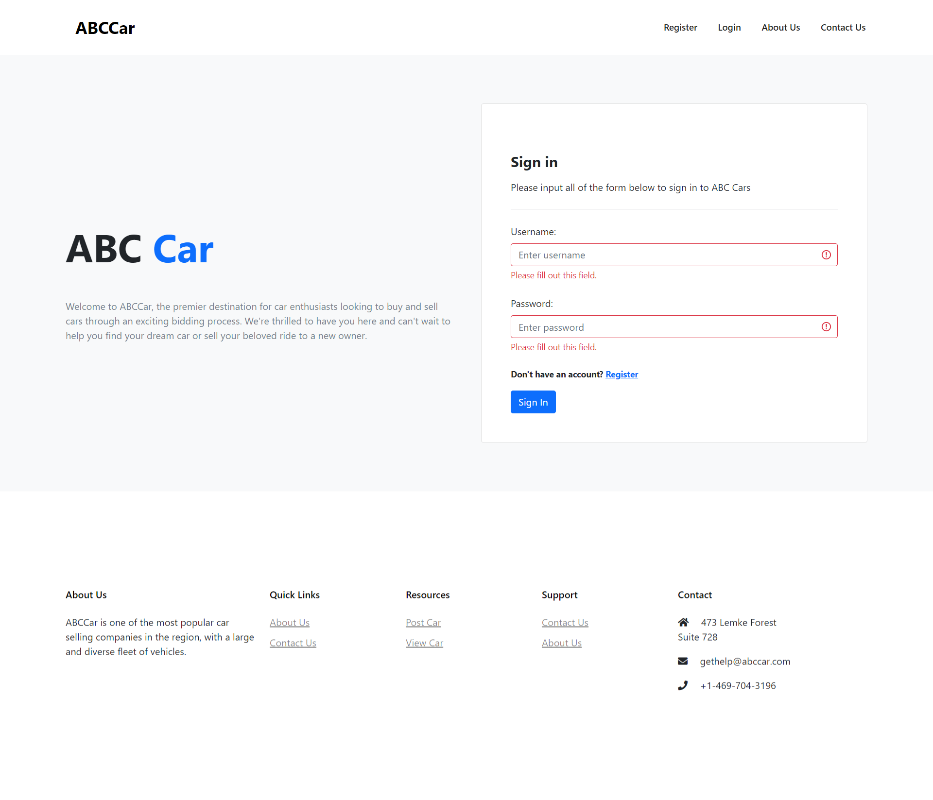

Register page

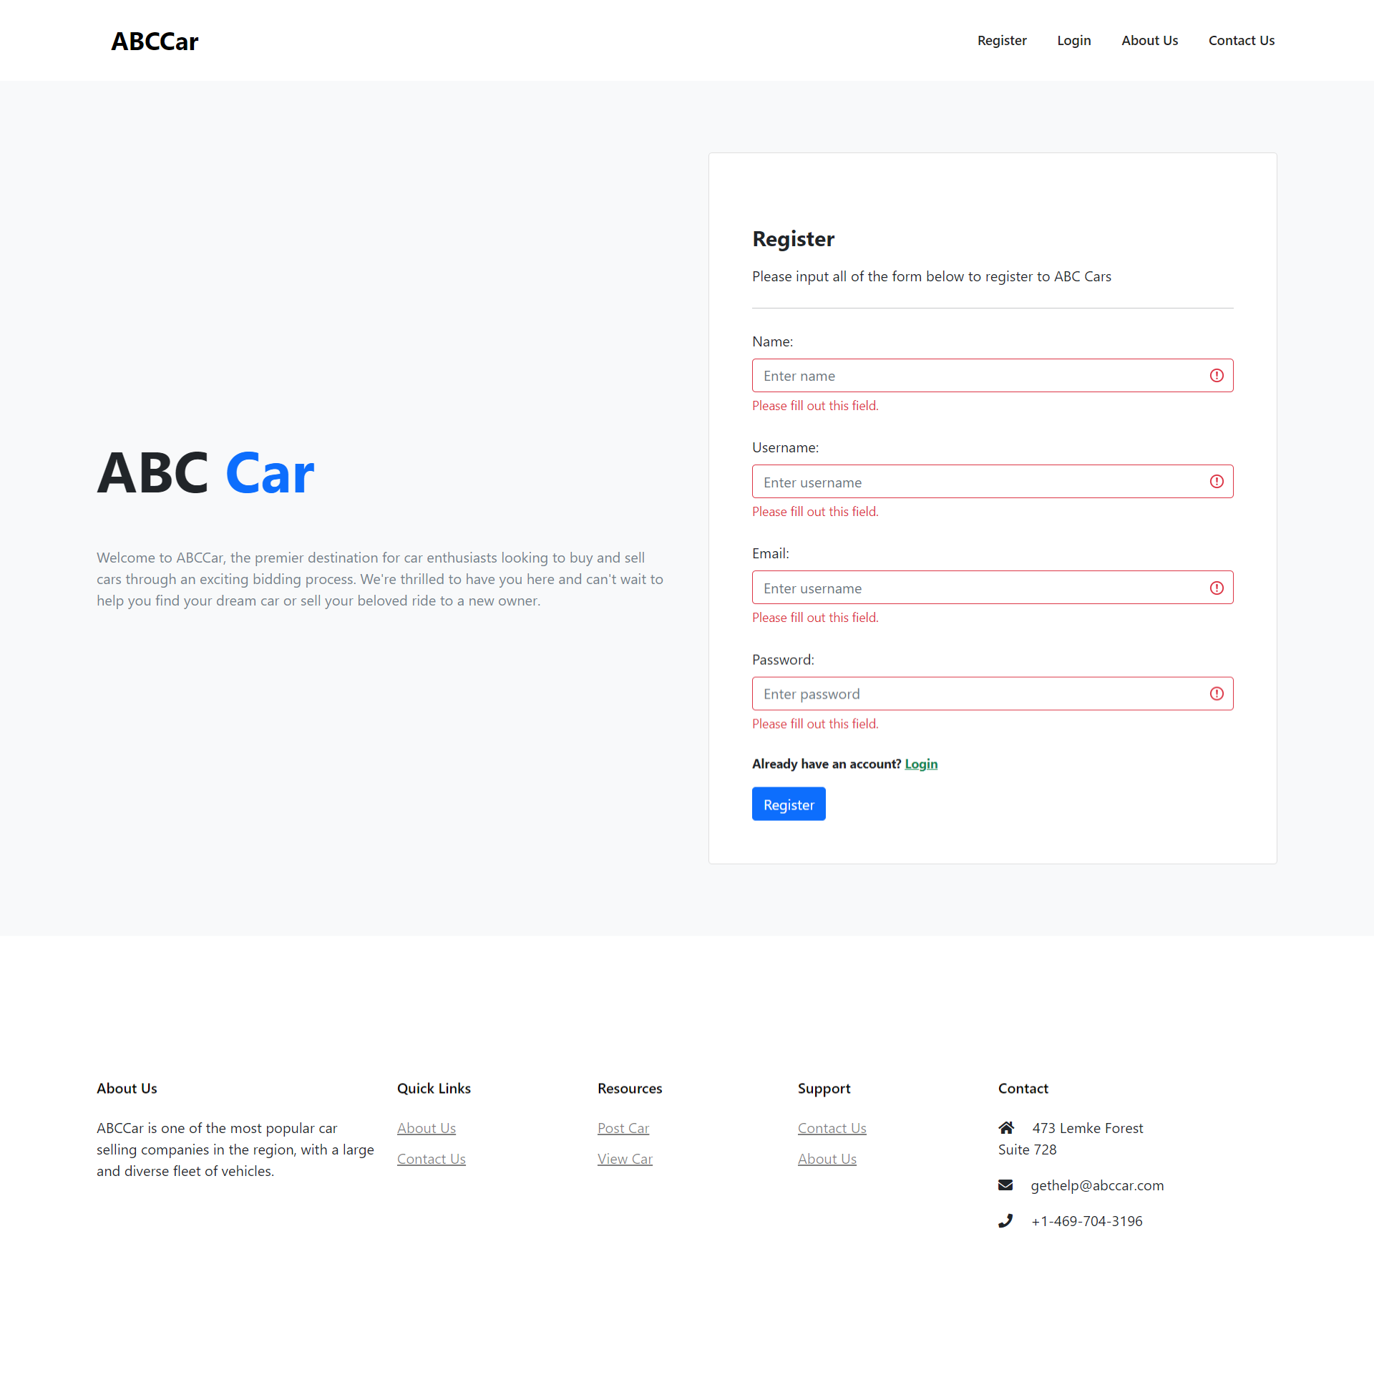

About us

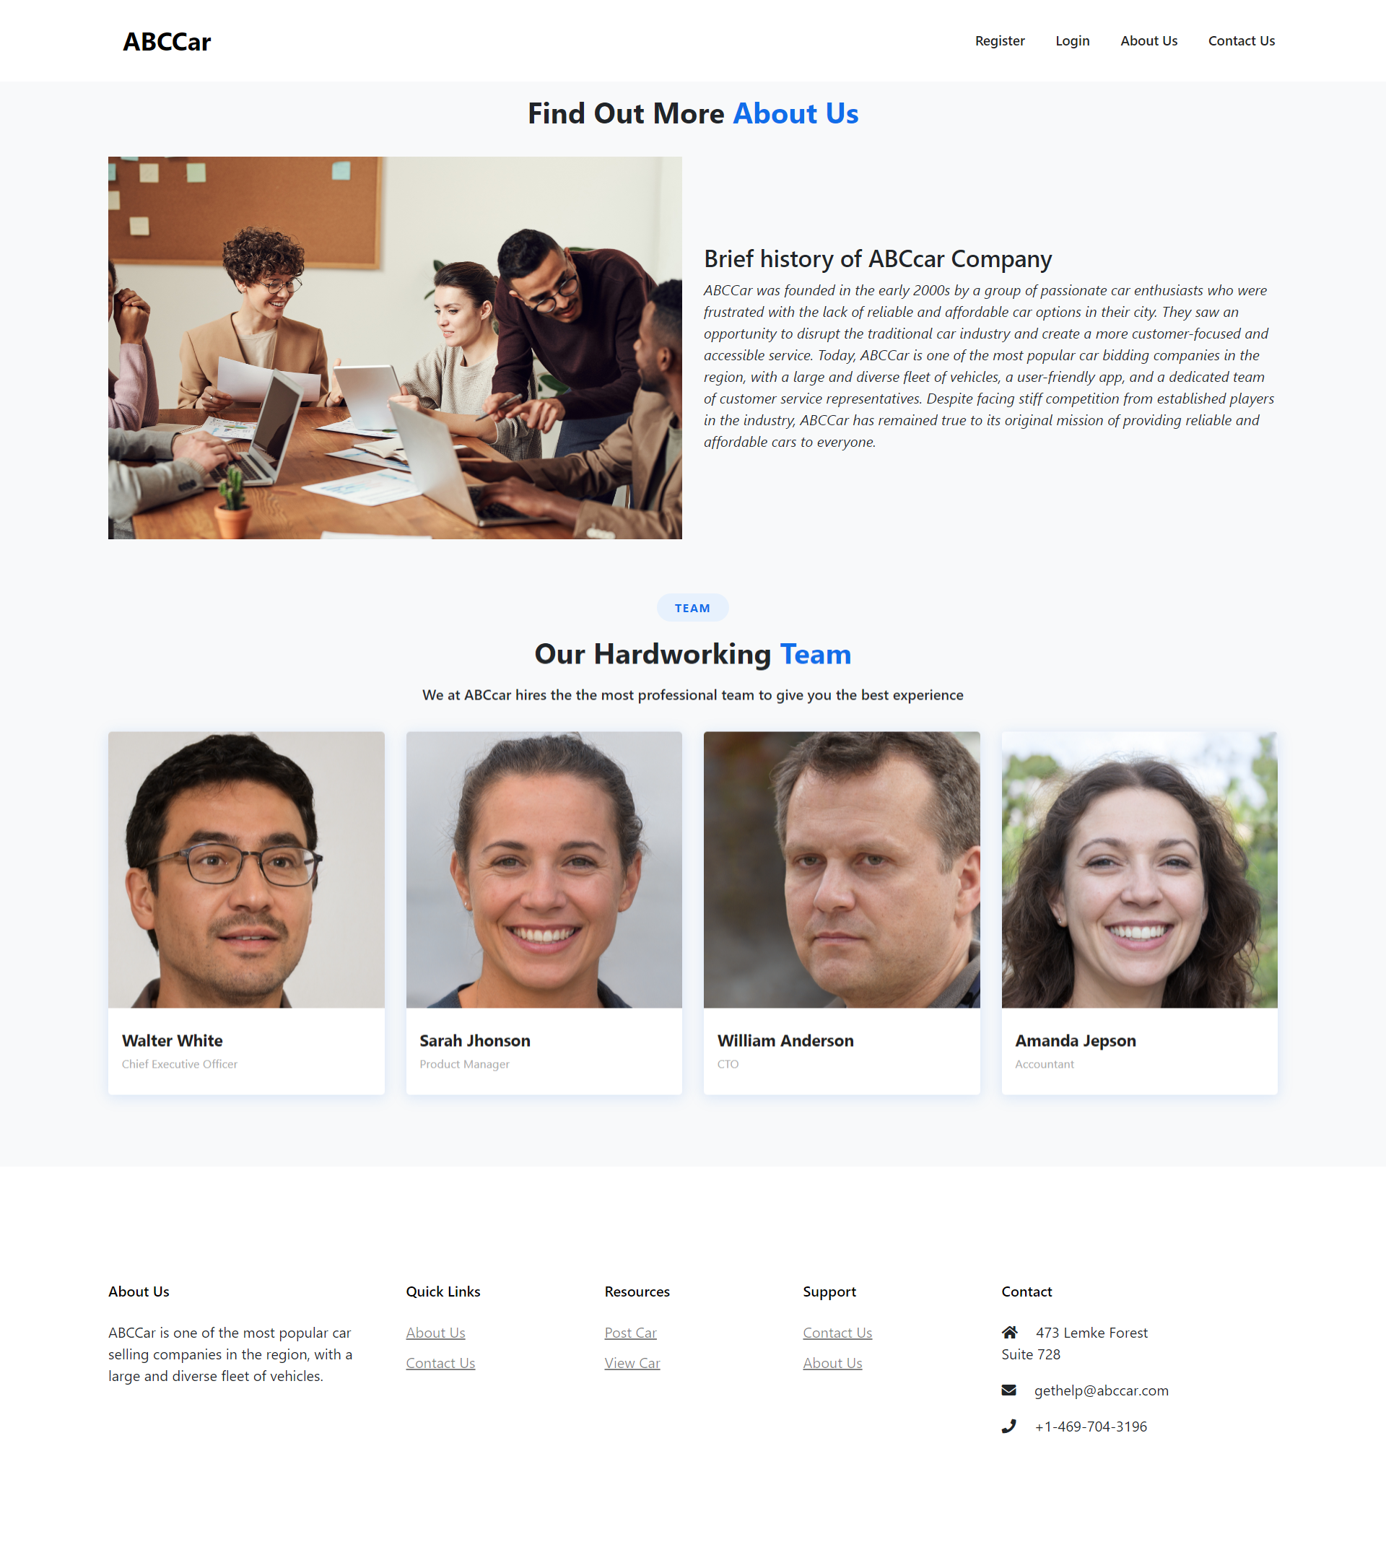

Contact us

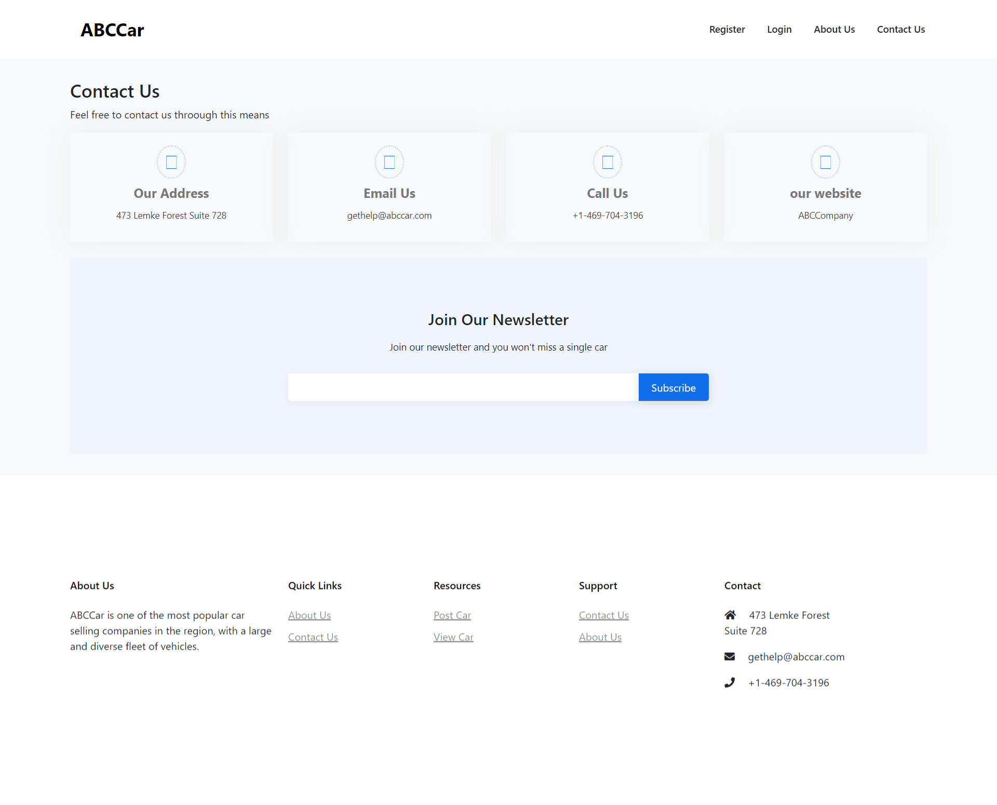

Home page

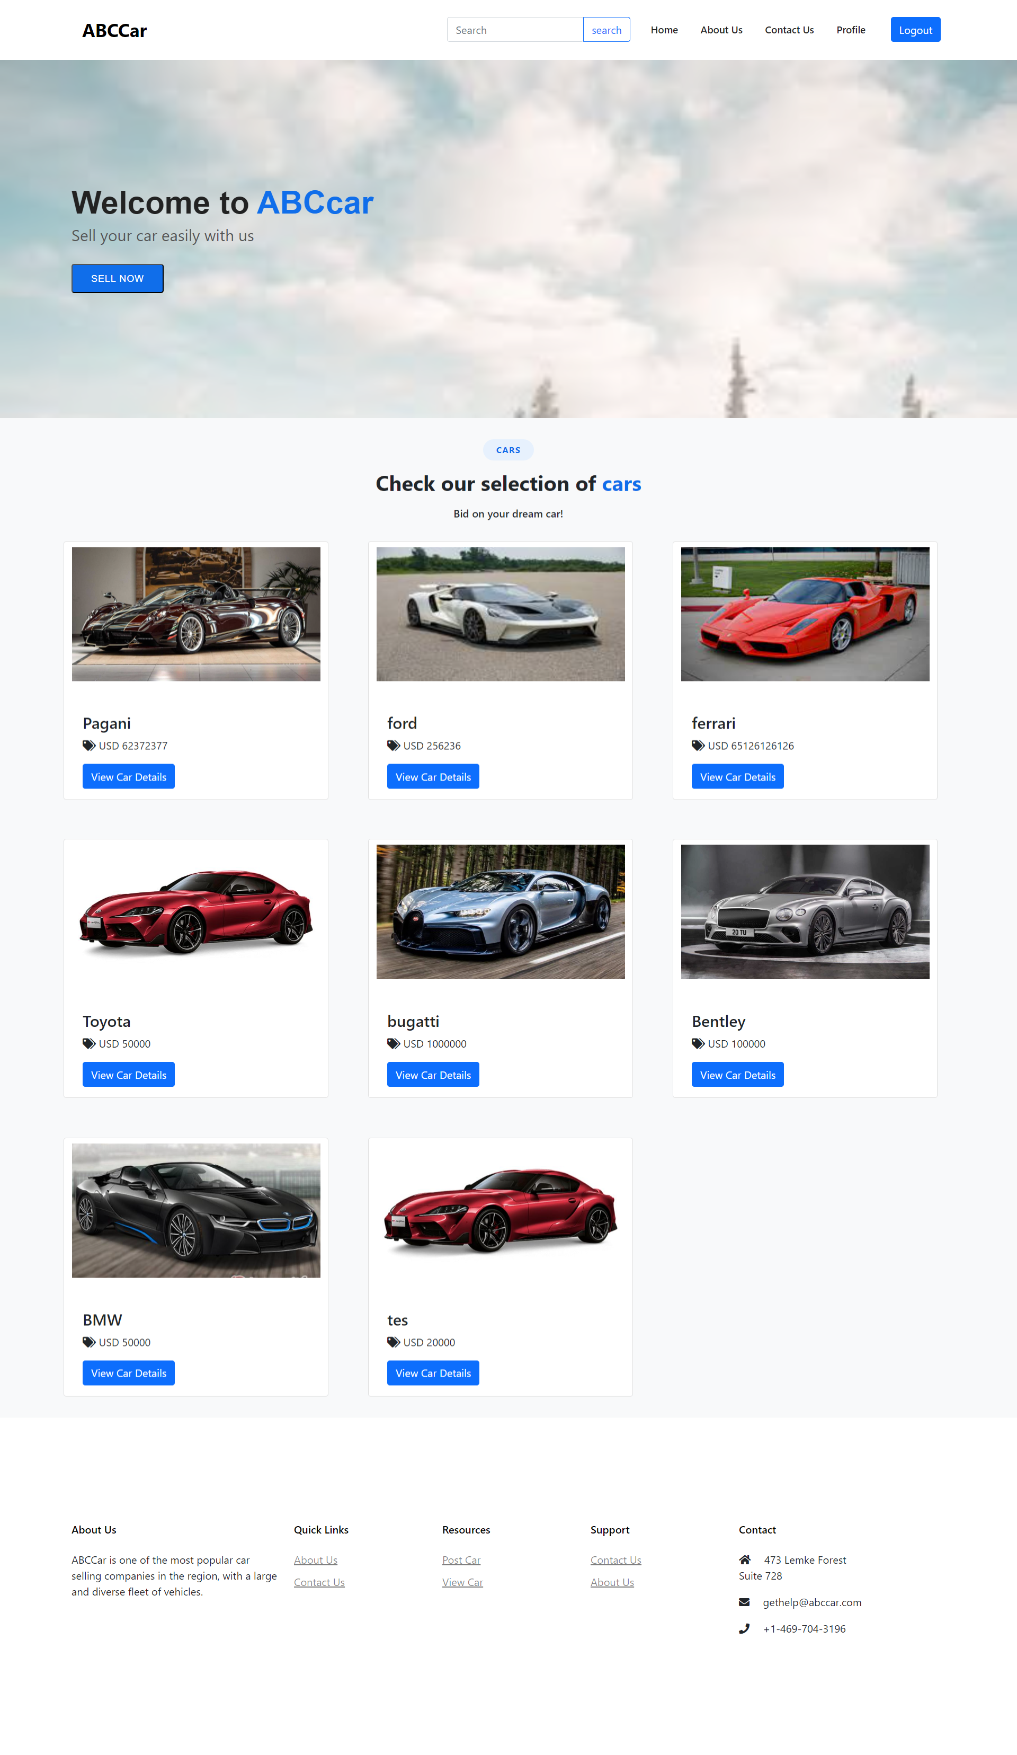

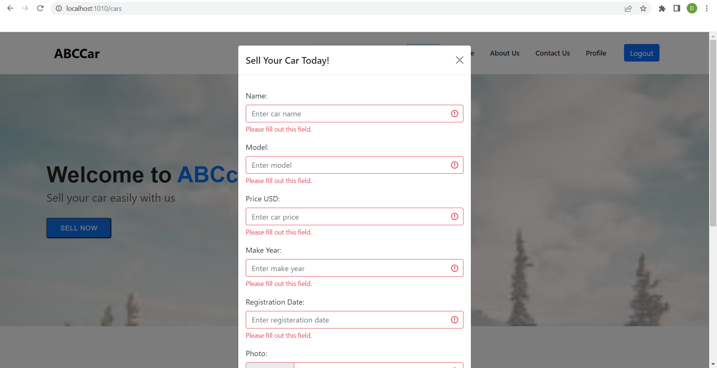

Profile page

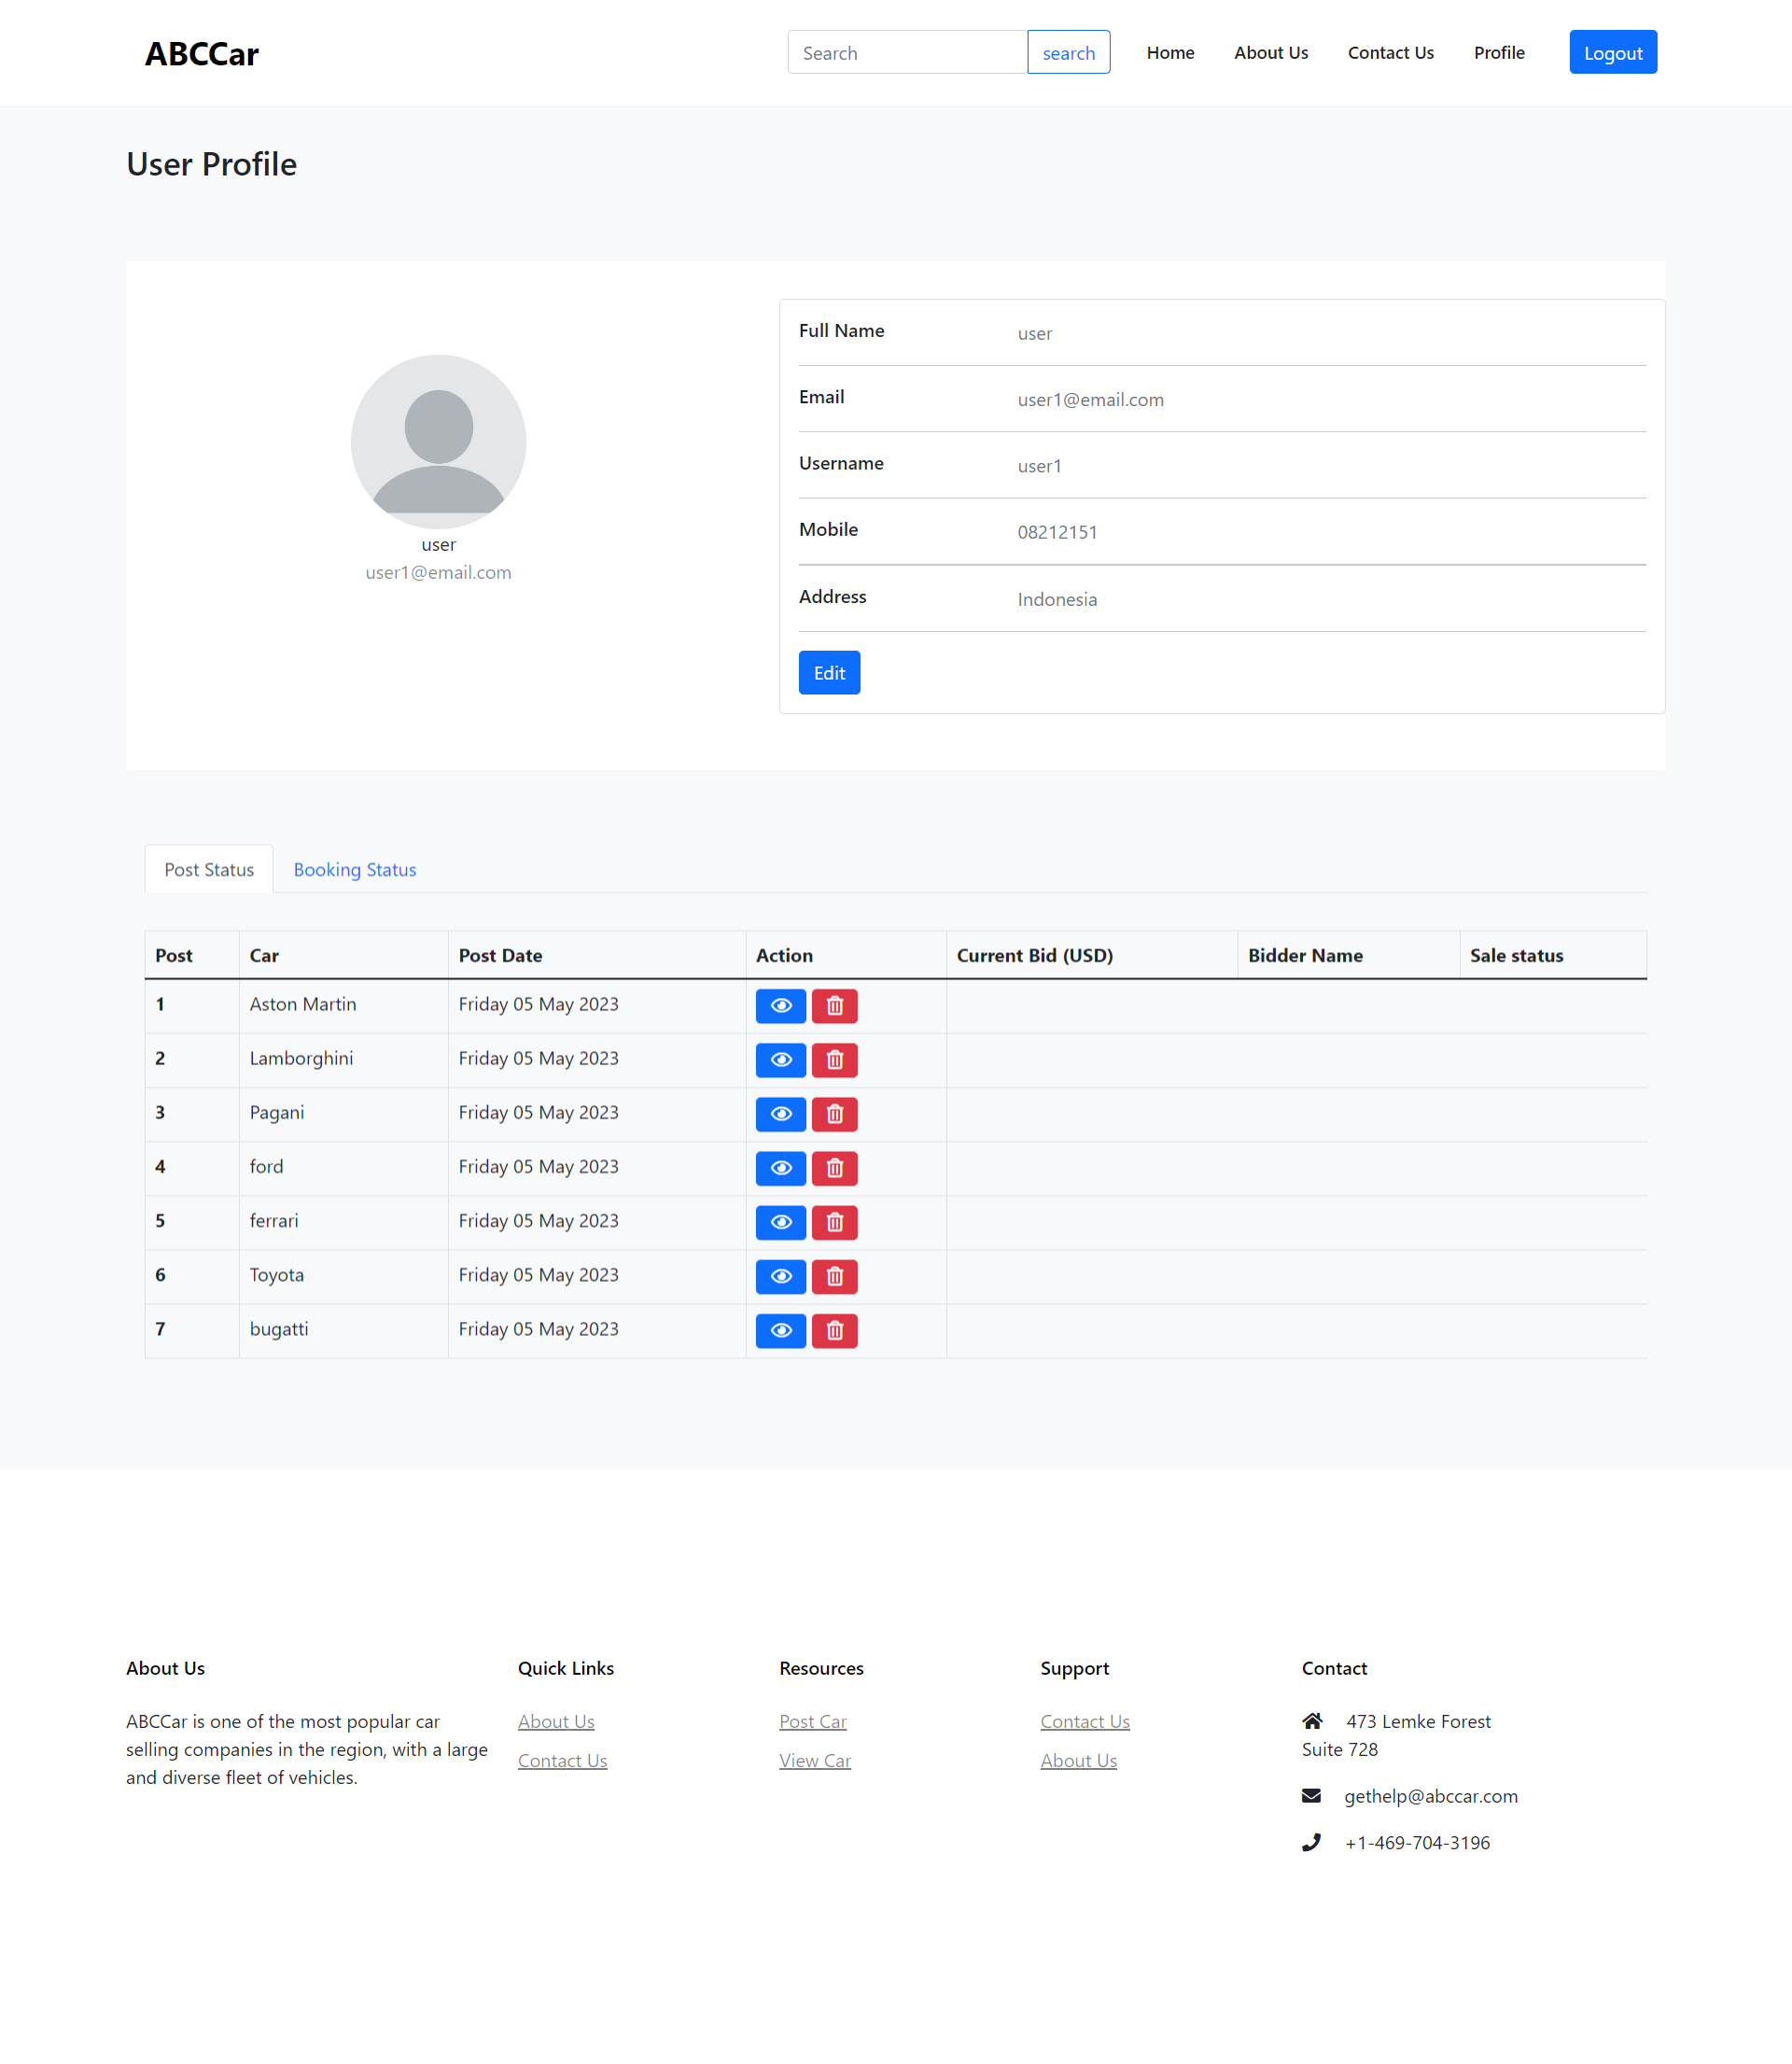

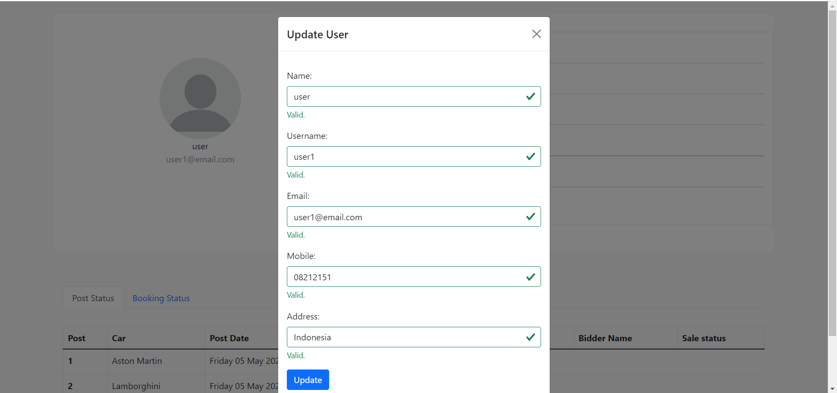

Search result page

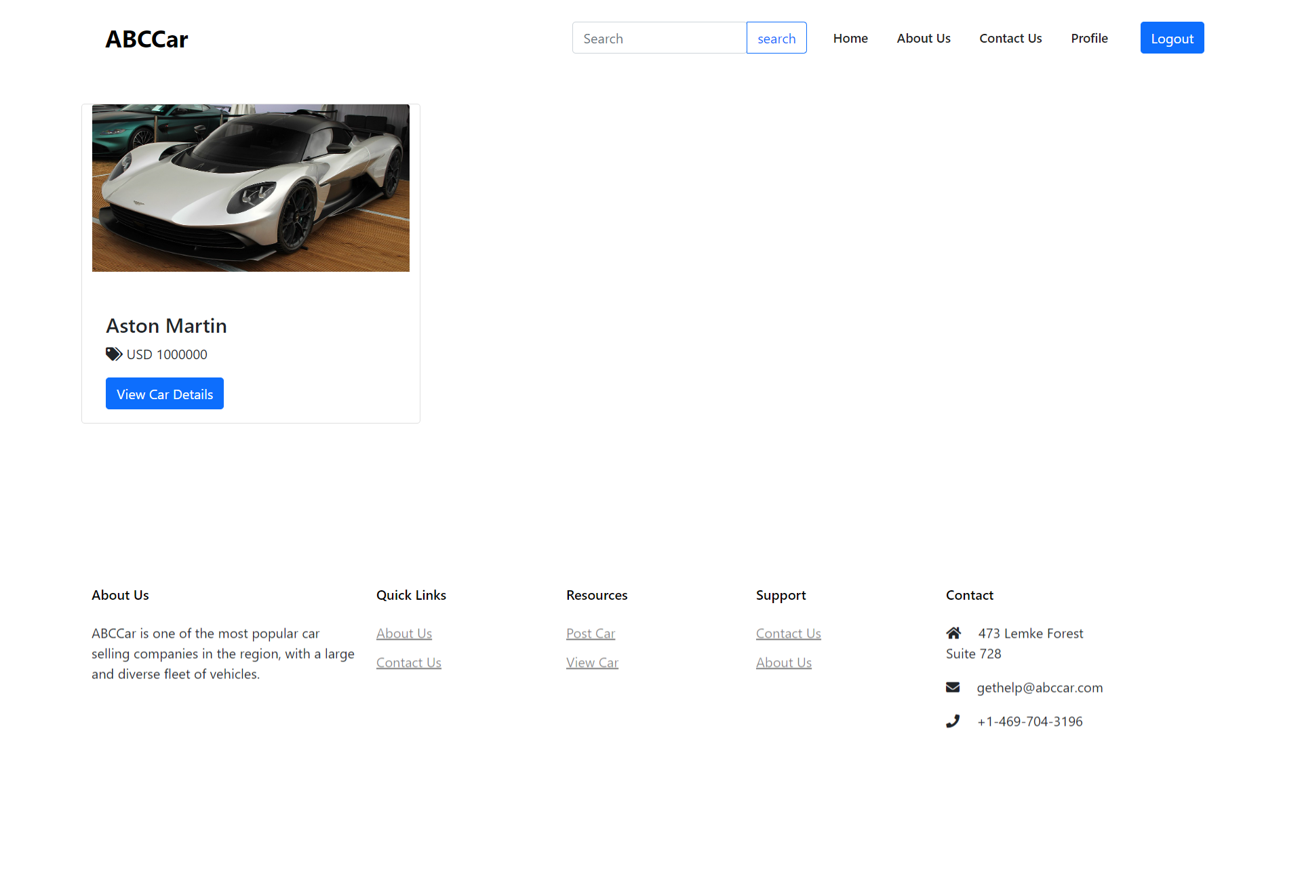

Car detail page  
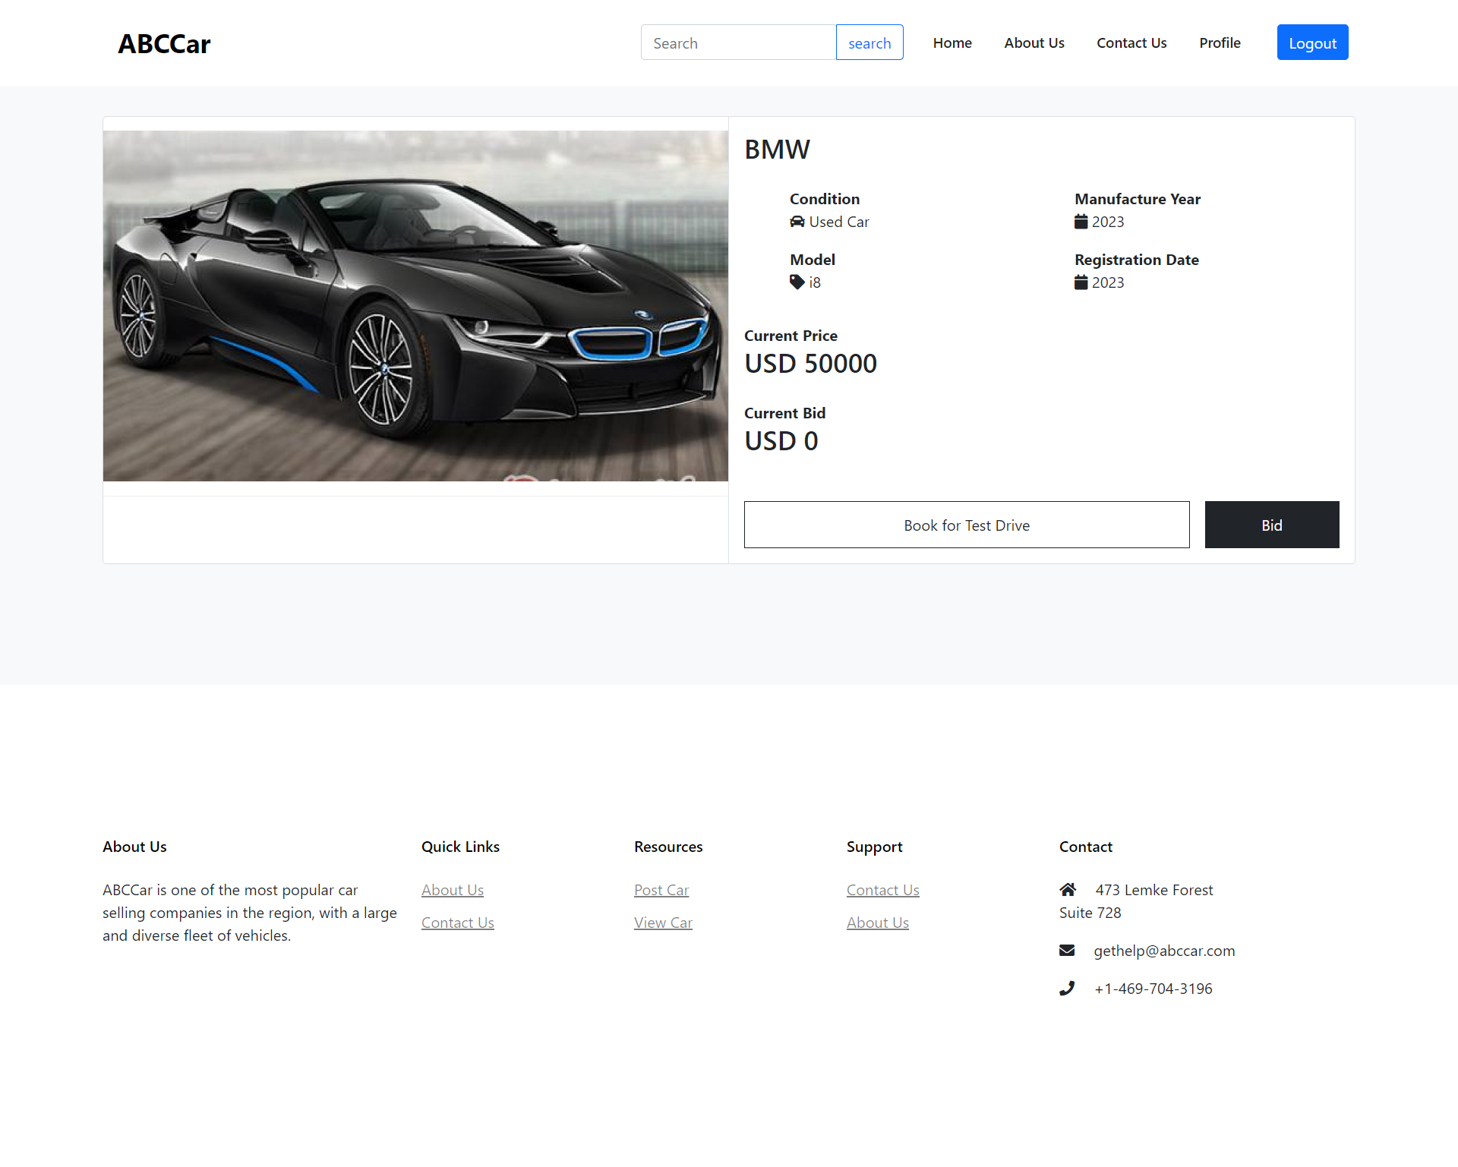

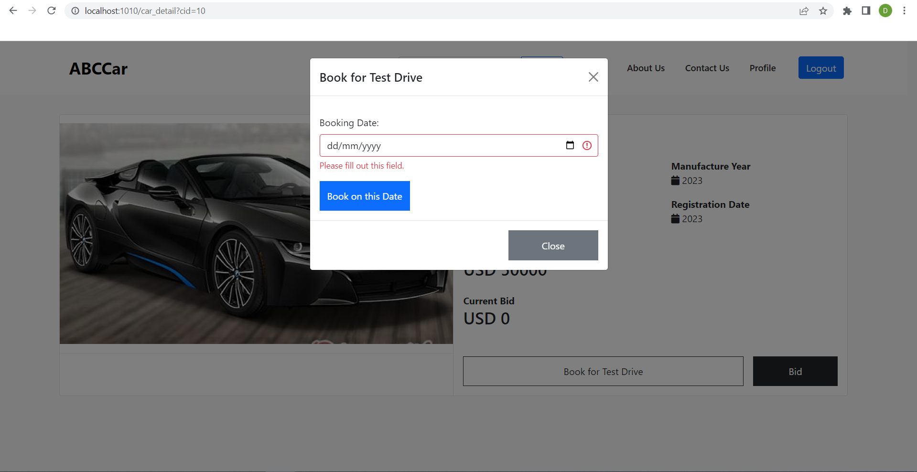

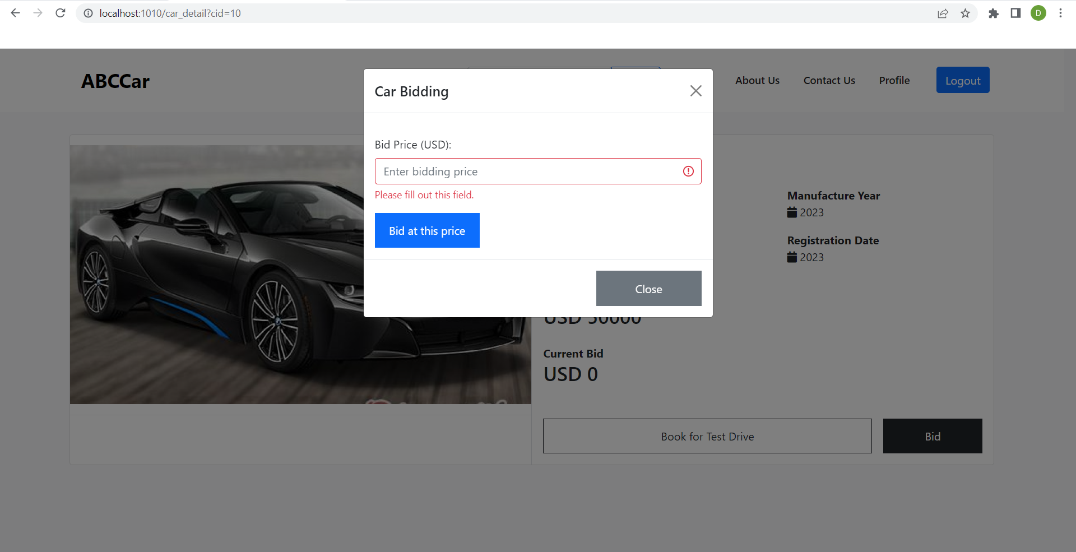

Car management

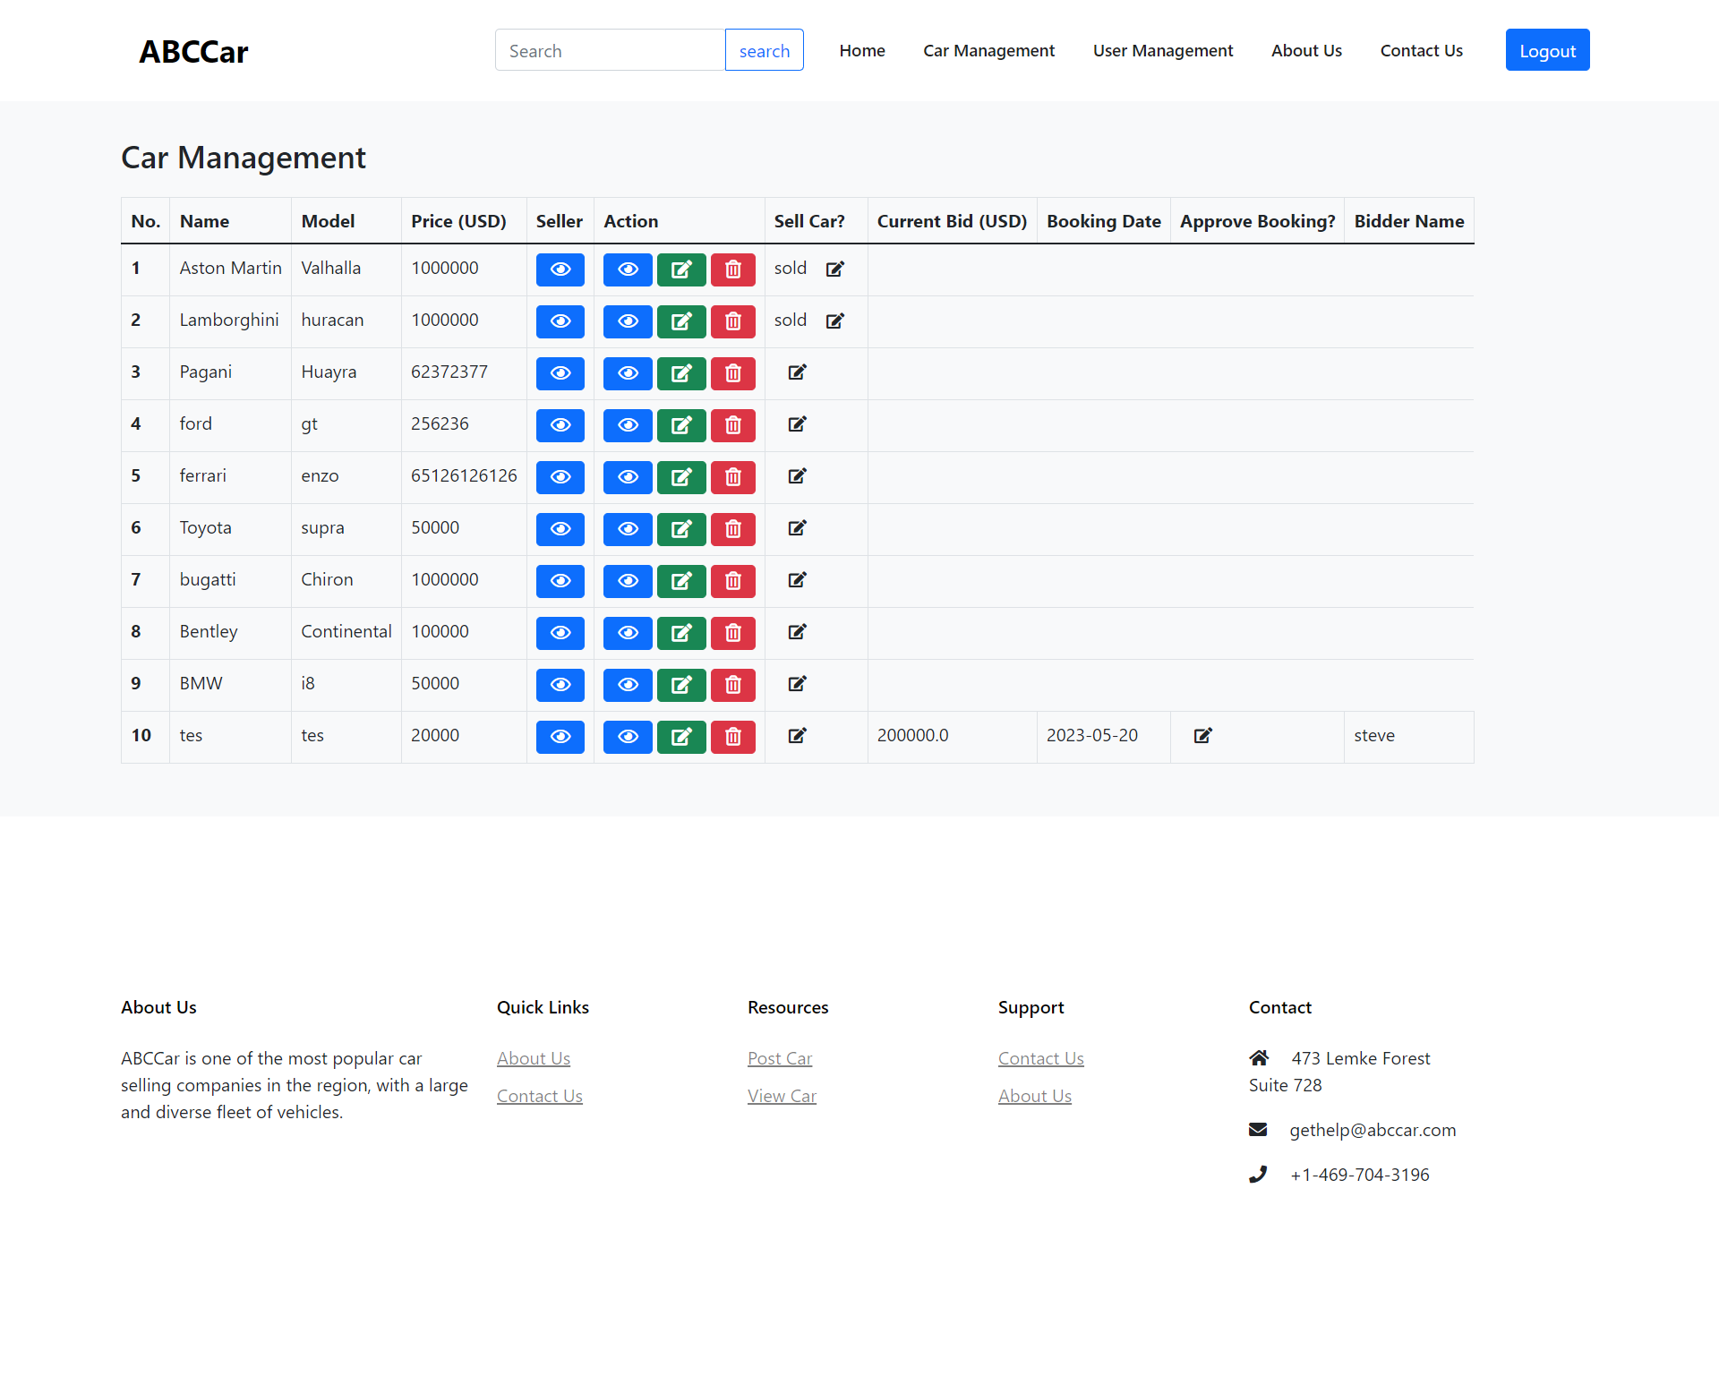

User management

